**S o u t h S u d a n S o u t h S u d a n**

**2 *Secondary***

***Secondary***

**2**

**M*a*them*a*tics**

***Secondary Mathematics*** has been written and developed by Ministry of General Education and Instruction, Government of South Sudan in conjunction with Subjects experts.This course book provides a fun and practical approach to the subject

of mathematics, and at the same time imparting life long skills to the pupils.

The book comprehensively covers the Secondary 2 syllabus as developed by

**Ministry of General Education and Instruction.**

**M*a*them*a*tics**

**Student’s Book**

**Each year comprises of a Student’s Book and Teacher’s Guide. The Student’s Books provide:**

Full coverage of the national syllabus.

A strong grounding in the basics of mathematics. Clear presentation and explanation of learning points.

A wide variety of practice exercises, often showing how mathematics can be applied to real-life situations.

It provides opportunities for collaboration through group work activities. Stimulating illustrations.

**All the courses in this primary series were developed by the Ministry of General Education and Instruction, Republic of South Sudan.**

**The books have been designed to meet the primary school syllabus, and at the same time equiping the pupils with skills to fit in the modern day global society.**

**Published by:**

**MOUNTAIN TOP PUBLISHERS**

**This Book is the Property of the Ministry of General Education and Instruction.**

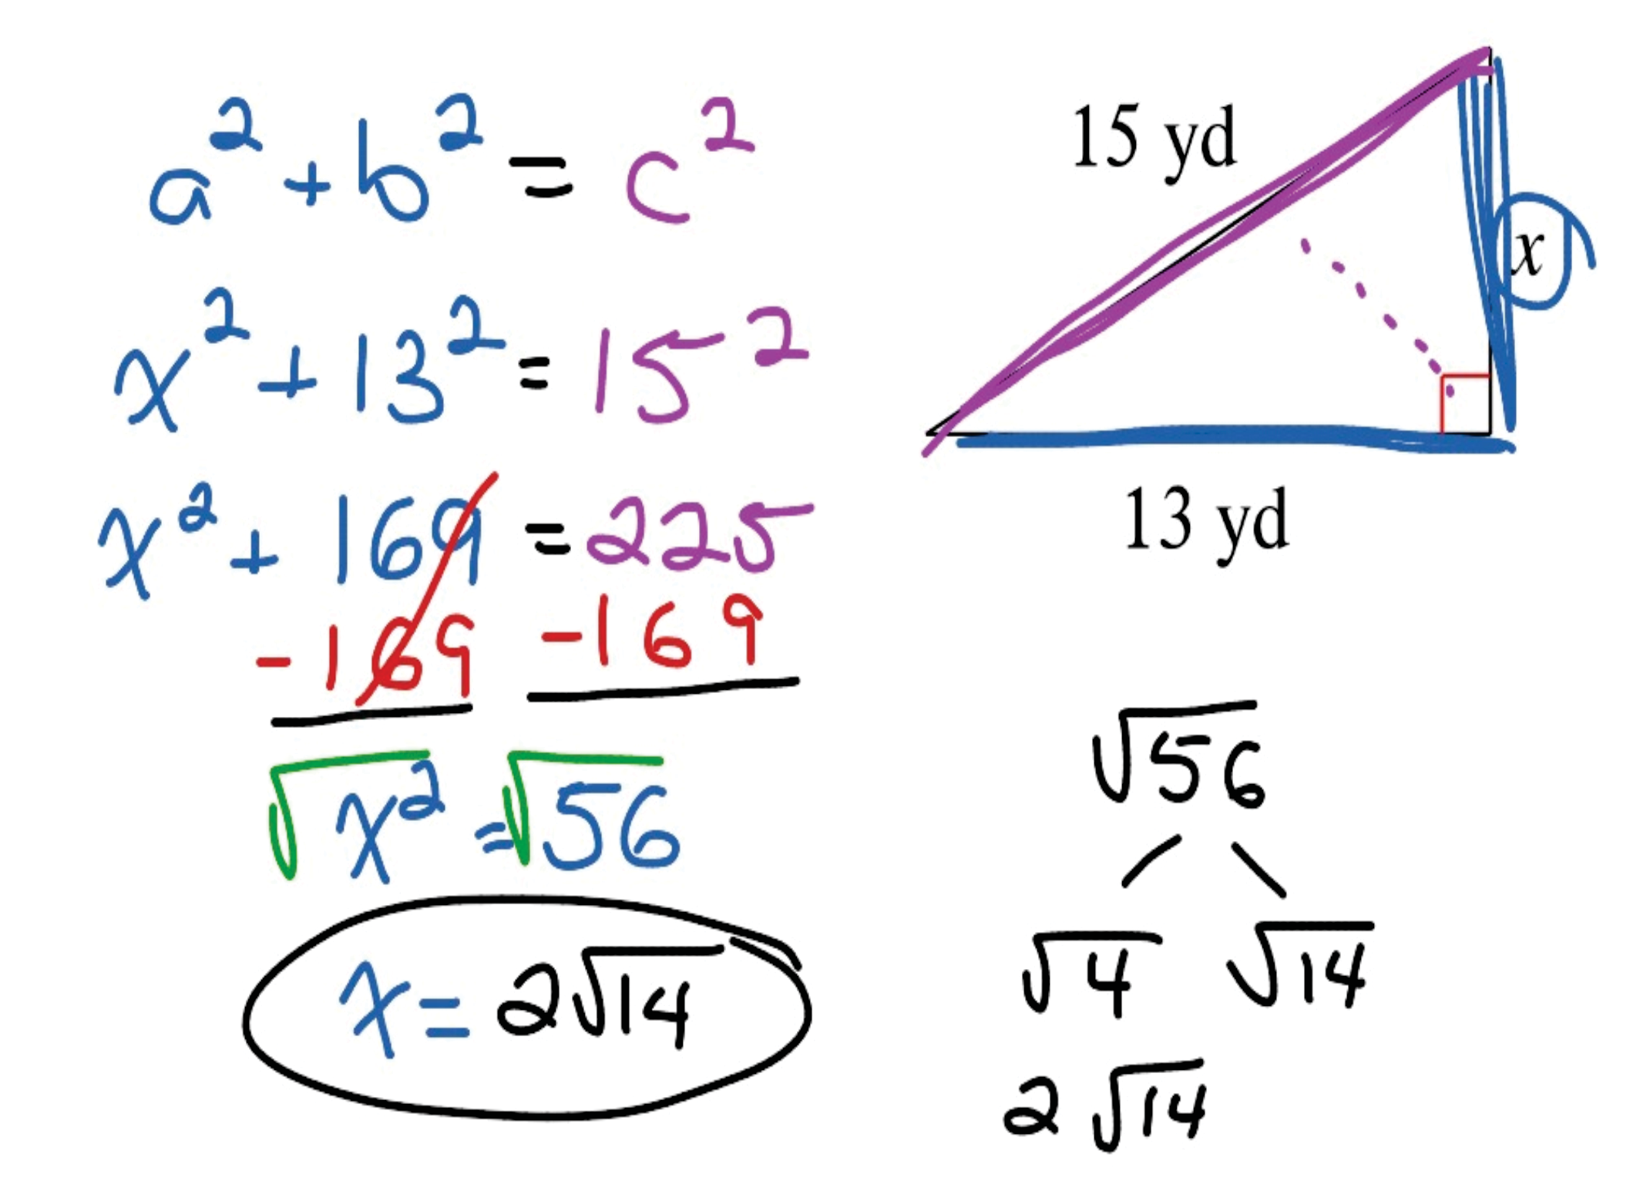

**This Book is not for sale.**

**Any book found on sale, either in print or electronic form, will be confiscated and the seller prosecuted.**

**Funded by:**

**This Book is the Property of the Ministry of General Education and Instruction.**

**This Book is not for sale.**

Funded by:

**Do’s 1.**

**2.**

**3.**

**4.**

**5.**

**6.**

**7.**

# How to take care of your books.

**Please cover with plastic or paper. (old newspaper or magazines) Please make sure you have clean hands before you use your book. Always use a book marker do not fold the pages.**

**If the book is damaged please repair it as quickly as possible. Be careful who you lend your schoolbook to.**

**Please keep the book in a dry place.**

**When you lose your book please report it immediately to your teacher.**

**Don’ts**

1. **Do not write on the book cover or inside pages.**
2. **Do not cut pictures out of the book.**
3. **Do not tear pages out of the book.**
4. **Do not leave the book open and face down.**
5. **Do not use pens, pencils or something thick as a book mark.**
6. **Do not force your book into your schoolbag when it is full.**
7. **Do not use your book as an umbrella for the sun or rain.**
8. **Do not use your book as a seat.**

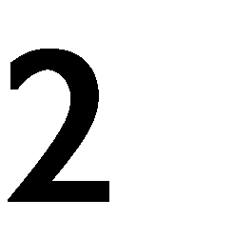

**PRI**



Mathematics

*Student’s Book 2*

©2018, THE REPUBLIC OF SOUTH SUDAN, MINISTRY OF GENERAL EDUCATION AND INSTRUCTION.

All rights reserved. No part of this book may be reproduced by any means graphic, electronic, mechanical, photocopying, taping, storage and retrieval system without prior written permission of the Copyright Holder. Pictures, illustrations and links to third party websites are provided in good faith, for information and education purposes only.

This book is the property of the Ministry of General Education and Instruction.



Funded by:

**THIS BOOK IS NOT FOR SALE**

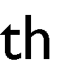



# Table of Contents

NUMERICAL CONCEPTS 1

Indices 1

Laws of indices 4

Surds 5

Operations with surds 5

Adding and subtracting 5

Simplifying Surds 6

Multiplication and division of surds 7

Commercial arithmetic 9

Foreign exchange rates 9

Simple interest 10

Income Tax 12

Calculation of income tax 12

Compound Interest 13

Appreciation/Depreciation 15

Hire Purchase 17

GEOMETRIC FIGURES AND PYTHAGORAS THEOREM 19

Review of surface area of shapes 19

Coordinate geometry 20

The equation of a line 23

Gradient 23

Proving Pythagoras’ theorem 26

The Unit Circle 27

ALGEBRA 33

Algebraic expressions and equations 33

Expansion 33

Expansion 36

Solving quadratic equations 38

Vectors 39

Sets 43

Venn diagrams 47

Matrices 54

Equality of matrices 55

Addition and subtraction of matrices 55

Scalar Multiplication 56

Matrix Multiplication 56

Determinant of a matrix 57

Solving simultaneous equations using matrices 59

Functions 61

Composite functions 62

Inverse functions 63

STATISTICS 69

Mean, Mode and Median 69

Assumed mean 71

Cumulative frequency 76

**UNIT 1**

# NUMERICAL CONCEPTS



**Indices**

Indices are a shorthand way of representing the repeated multiplication of a number by itself.

For example, 2  2  22 in this case, 2 is the base and 2 is known as the **exponent**

or **index** or **power**

or 2  2  2  23 , in this case, 2 is the base and 3 is the **exponent** or **index** or

**power**

**Indices are used to perform operations on large numbers easily without the use of a calculator.**

***Example***

1. Using your calculator or otherwise evaluate, 16  32
2. Using indices, evaluate, 16  32

***Solution***

* 1. 16  32  512
  2. Using your calculator or otherwise find that, 16  24 ,32  25

Therefore, 16  32  24  25  29  512

##### Activity 1

1. In groups, write the following using indices and identify the base and index.
   1. 5 5 5 5 5 5 5 5
   2. 2  2  2  2  22  2  2
   3. *x*  *x*  *x*  *x*  *x*  *x*  *x*  *x*
   4. *y*  *y*  *y*  *y*
2. Using your calculator,
   1. Find the value of the following, then simplify.

Example: 26  24 1024  2 *p* where *p* = 10

23  22   2 *p*

24  23   2 *p*

34  32   3 *p*

53  52   5 *p*

where *p* = ……….. where *p* = ……….. where *p* = ……….. where *p* = ………..

104 102  .......... .... 10 *p* where *p* = ………..

* 1. Complete the general rule *ya*  *yb*  .......... ....
  2. Will your general rule work on large numbers? Use your calculator to check your rule for 220  210.
  3. Will your rule work for fractional powers? Use your calculator

7 5

to check your rule for 32  32

1. Using your calculator
   1. Find the value of the following, then simplify as shown.

26  24  4  2 *p* where *p* = 2

23  22  .........**.** ....2 *p* where *p* = ………..

24  23  .........**.** ....2 *p* where *p* = ………..

34  32  3*p*

53  52  5 *p*

where *p* = ……….. where *p* = ………..

104 102  ............10*p* where *p* = ………..

* 1. Complete the general rule

*ya*  *yb*  ............

* 1. Will your general rule work on large numbers? Use your

calculator to check your rule for

220  210.

* 1. Will your rule work for fractional powers? Use your calculator

7 5

to check your rule for 32  32

1. Based on your investigation above,
   1. Find the value of

23  25

22  24 .

* 1. Hence, complete the rule numbers.

*ya*  *yb*

*yc*  *yd*

; *a*, *b*, *c* and *d* are rational

22  23

1. a) Using your investigation above, find the value of

b) Hence complete the rule *an*  *an* 

1. a) Using you calculator to evaluate

23  22

1

2

1. 22 and

1

3 3

1. 33 and
2. ​

1

42 and

2

83 and

4

 2

3 8

1

1. Hence complete the rule *an* 

*m*

and *a n* 



*an*

g)

*a**n*  1

*m*

 

*a n*  *n a*

*a*0  1

e)

f)

*m*

1

*a n*  *n a*

d)

(64)2 = 64×2 = 68

**index** 𝒎𝒏

*Example*

**- note that** 𝒎 **and** 𝒏 **have been multiplied to yield the next**

*mn*

*n*

*m*

*a*   *a*



c)

Laws of indices:

To manipulate expressions involving indices, we use rules known as laws of indices. The laws should be used precisely as they are stated-do not be tempted to make up variations of your own.

1. *am*  *an*  *am**n* **- when expressions with the same base are multiplied, the indices are added.**

*Example*

76 × 74 = 76+4 = 710

1. *am*  *an*  *am**n* - **when expressions with the same base are divided, the indices are subtracted.**

*Example*

85

= 85−3 = 82

83

##### Exercise 1: To be done in pairs, show the steps

1. Using the rules above, evaluate:

1

* 1. 92

2

* 1. 83

2

64 3

* 1. ​

23

2

 64  3

125 

vi)

1

81 4

* 1.  

1. Simplify the following expressions:

2



1

i) (64*a*6 ) 2

ii) 4 16*x*8

iii) (8 *p*) 3

(4 *p*)2

2 2

iv) *x y*

25*x*4

**Surds**

1

From our previous work, we have seen that 42 is the same as 4 . Numbers such as 4, 6, 5 are known as surds.

A **surd** is a number that is written using the square root sign(√).

Surds such as 4, 9, 16 are **rational** since 4  2, 9  3, 16  4 .

Surds such as 2, 3, 5 are **irrational** because they cannot be written as exactly.

**Operations with surds**

Adding and subtracting

We add surds in the same way we do like terms in algebra. For example:

just as *a* + *a* = 2*a*, then 2  2  2 2

Just as 6*b* - 2*b* =4*b* then 6 3  2 3  4 3

##### Exercise 2

1. Using your calculators, evaluate:

i) 

2

2

ii) 

7

7

*a*

*a*

hence complete the rule

 

1. Using you calculator, evaluate

i)

 3 and

#### 2  3

1.  and

2

3

5

3  5

6

2

6

2

1. and
2. and

7

2

7

2

*b*

Hence complete the rules i)

*a*

ii) 

*a*

*b*

 

1. Using the observation above, simplify the following without using calculators:
   1. 3  4

2

2

####  2(1 7)

7

iii)(√2)2

iv) (√3)3



v) ( 4 )2

√2

**Simplifying Surds**

A surd is in simplest form when the number under the square root sign is the smallest possible integer.

For example: Write 8 in its simplest form

8  4  2



 4  2

 2 2

##### Exercise 3

1. Simplify the following surds

a)

12

b)

1. d)

### Multiplication and division of surds

24

48

108

##### Exercise 4

2

1. Consider the fraction 6
   1. Since 2 is a factor of 6, split 6 into 3  

2

2

* 1. Hence, simplify 6

2

1. Can the method of splitting the numerator be used to simplify 7 ?

2

1. Consider the fraction 7 ,

2

* 1. If we multiply this fraction by are we changing its value?

2

2

* 1. Simplify

7 by multiplying both its numerator and denominator by

1. The method in question 3 is called “rationalizing the denominator”. Will this

2

2

method work for all fractions of the form values?

*a*

*b* where *a* and *b* are positive integer

1. From the observation above, rationalize the denominator for the following fraction:
   1. 6 b)

5

7 3

2

c)

1. 26

##### Exercise 5

4 5

3

13

Fractions of the form

*c* can also be simplified to remove the square root

from the denominator. We do this by multiplying it by its **conjugate**. Remember that (𝒂 + 𝒃)(𝒂 − 𝒃) = 𝒂𝟐 − 𝒃𝟐 𝒅𝒊𝒇𝒇𝒆𝒓𝒆𝒏𝒄𝒆 𝒐𝒇 𝟐 𝒔𝒒𝒖𝒂𝒓𝒆𝒔

*a*  *b*

1. Expand and simplify.
   1. 2 

32  3

b) 

3 1

3 1

1. What do you notice?
2. Show that for any integers 𝑎 and 𝑏, the following products are integers:
   1. *a* 

*b* *a*  *b* 

b) 

*a*  *b*

*a*  *b*

##### Note: 

*a*  *b* **is the conjugate of** 

*a*  *b*

1. Copy and complete the following statement:
   1. To remove the square roots from the denominator of a fraction, we can multiply the denominator by its …………………………….
   2. What must we do to the numerator of the fraction to ensure we do not change its value?

From the investigation above, we should have found out that:

***To remove the square roots from the denominator of a fraction, we multiply both the numerator and the denominator by the conjugate of the denominator.***

##### Exercise 6

1. Rationalize the denominator and simplify.

1

1. 5√7

* 1. 3  2

2

* 1. 3  2

2

2

√5−√2

2

1. 3  5
   1. 2 

2

4

3  3

* 1. ​

1. √2+1

√2+√5

1. √3−√2

√6



**Commercial arithmetic**

Foreign exchange rates

Different currencies have different value. Some currencies are stronger than

others. For example the American Dollar $ is stronger than most currencies in the world.

##### Discussion questions:

* Who determines the strength of the currency for each country?
* Why do we need to convert know the conversion rate of currency to other currencies?

In 2013, 100 𝑆𝑆𝑃 = 𝐾𝑠ℎ 79, this means that 1SSP = KSh 0.79

The table below shows the various exchange rates for 1SSP into various currencies

|  |  |
| --- | --- |
| 100 SSP | Kenya Shilling Ksh 80 |
| 13000 SSP | US dollar $ 100 |

|  |  |
| --- | --- |
| 17500 SSP | British pound 100 |

##### Exercise 7

Use the table above to calculate the amount of money Joseph has in SSP if he has

* 1. Ksh 10 000 b) US dollars 1000 c) British pounds 5000

### Simple interest



Sarah needs to borrow SSP 2000 in order to buy furniture. She's approved for two different loans. Loan one allows her to borrow SSP 2000 now, provided that she pay off the loan by returning SSP 2200 exactly one year from the day that she borrows the money. Loan two offers her SSP 2000 upfront as well, with a similar loan period of one year, at an annual interest rate of 7%. Which is the better deal for Sarah?

The amount borrowed or invested is called the **principal**. Using the example above, when Sarah borrows SSP 2000 to buy furniture, we say that the principal is SSP 2000.

It's customary for financial institutions to quote a quantity called the **interest rate** as a percentage. This interest rate represents a ratio of the principal borrowed or invested. Typically, this interest rate is given as a percentage per year, in which case it is called the **annual interest rate**. For example, if we borrow SSP 100 at an annual rate of 5%, it means that we will be charged 5% of SSP100 at the end of the year, or SSP 5.

The **loan period or duration** is the time that the principal amount is either borrowed or invested. It is usually given in years, but in some cases, it may be quoted in months or even days. If that is the case, we need to perform a conversion from a period given in months or days, into years.

The simple interest formula allows us to calculate *I*, which is the interest earned or charged on a loan. According to this formula, the amount of interest is given by *I = Prt*, where *P* is the principal, *r* is the annual interest rate in decimal form, and *t* is the loan period expressed in years.

###### Example

The second offer that Sarah has received is to borrow a principal amount *P* = SSP 2000, at an annual rate of 7%, over *t* = 1 year. The rate *r* must be converted



from a percentage into decimal form, which means that we divide the percentage value 7% by 100 to get *r* = 0.07.

We now calculate the amount of interest Sarah would be charged if she accepts the loan offer just described:

*I = Prt* = (2000) (0.07)(1) = SSP 140.

Following our example, we determined that if Sarah accepts the second loan, the interest that she will owe the bank is SSP 140. So, how much would Sarah have to pay the bank in order to pay off her debt? She would have to pay back the money she borrowed, or the principal, which is SSP 2000, and she would have to pay the bank the interest we calculated, in which *I* = SSP 140. Thus, she will owe the bank SSP 2000 + SSP 140, which equals SSP 2140. We note that this is still less than the SSP 2200 Sarah would have to pay if she accepts Loan one.

Obviously, Loan two is the better choice.

##### Exercise 8: To be done in groups

* + 1. Anne borrows SSP 1000 from her friend in order to start a business. She agrees to pay her friend SSP 1200 at the end of 1 year.
       1. How much interest does she pay her friend?
       2. What percentage is this interest of the amount borrowed?
       3. If she borrowed SSP 2000 using the same percentage rate, how much will she pay at the end of 1 year? 2 years?
    2. David deposits SSP 300 in his bank account. The bank tells him that if does not withdraw this money in 1 year, they will pay give him back SSP 350.
       1. How much interest is the bank paying?
       2. What is the percentage rate?
       3. How much will get if he deposits SSP 1000 for 1 year? 2 years?
    3. How much interest will Susan get if she lends Alice SSP 500 for 1 year at 10% interest? What is the total amount that Alice pays back?
       1. How much interest will Ali get if he deposits SSP 2000 in his bank for 5 years at 5% interest? What is the total amount that Ali gets?
       2. How much interest do I pay if I borrow SSP P for T years at R% interest? How much do I pay in total?

Income Tax

When people work they do so in return for payment in some form or other. All the money that a person earns from whatever sources is described as the person’s **gross income.**

Any person who earns money is liable to pay tax on his income to the government. This tax is called **income tax.**

**Taxable income** is the amount on which tax is levied. This is equal to the gross income less any special benefits on which taxes are not levied.

The rates of income tax are given by the government. The table below shows rates applicable from 2013.

Calculation of income tax

***Example***

Mr. Eric earns a total of SSP 4,800 per year. Calculate how much tax he should pay per month.

***Solution***

4800 ÷ 12 = 𝑆𝑆𝑃 400

Since Mr. Lado’s income is above SSP 300 per month, his tax rate is 10%

400 × 10% = 𝑆𝑆𝑃 40

##### Exercise 9

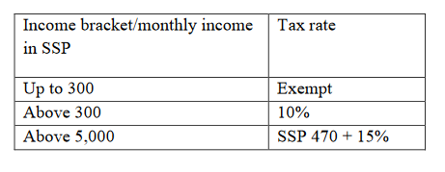

1. Find the general incomes of people working in different professions around or in your school. E.g. teachers, doctors, nurse, politician etc.
2. Using the rates given above, calculate the income tax they pay the government.

### Compound Interest



##### What is 'Compound Interest'?

Compound interest (or compounding interest) is interest calculated on the initial principal and also on the accumulated interest of previous periods of a deposit or loan. Compound interest can be thought of as “interest on interest,” and will make a sum grow at a faster rate than simple interest, which is calculated only on the principal amount. The rate at which compound interest accrues depends on the frequency of compounding; the higher the number of compounding periods, the greater the compound interest.

##### Compound Interest Formula

Compound interest is calculated by multiplying the principal amount by one plus the annual interest rate raised to the number of compound periods minus one.

The total initial amount of the loan is then subtracted from the resulting value.

##### The formula for calculating compound interest is:

Compound Interest = Total amount of Principal and Interest in future (or Future Value) less Principal amount at present (or Present Value)

= [𝑃 (1 + 𝐢)𝑛] – 𝑃

= 𝑃 [(1 + 𝐢)𝑛 – 1]

(Where P = Principal, i = nominal annual interest rate in percentage terms, and n

= number of compounding periods.)

###### Example 1

Take a three-year loan of SSP 10 000 at an interest rate of 5% that compounds annually. What would be the amount of interest?

###### Solution

In this case, it would be: SSP 10 000 [(1 + 0.05)3] – 1 = SSP 10 000

[1.157625 – 1] = SSP 1576.25.

###### Example 2

Find the present value of an investment if the future value is SSP 1000. The investment pays 4.5% compounded semiannually for seven years.

r = 0.045

ppy = 2

i = 𝑟 = 0.045= 0.0225

𝑝𝑝𝑦 2

t = 7

n = (t)(ppy) = (7)(2) = 14 P = ?

A = 1,000 I

P = A(1 + i)−n = 1000(1.0225)−14 = SSP 732.34

The present value for the corresponding simple interest problem was SSP

760.46. Remember that with compound interest more interest is earned because the interest is periodically added to the balance. Consequently, the interest itself earns interest. Since more interest is being earned, it requires less of an investment to achieve the same future value.

Suppose the interest is compounded daily instead of semiannually. Find the present value.

r = 0.045

ppy = 365

i = 𝑟

= 0.045

𝑝𝑝𝑦

t = 7

365

n = (t)(ppy) = (7)(365) = 2555 P = ?



A = 1,000 I

P = A(1 + i)−n = 1000((1 +

0.045

)

365

−2555

= SSP 729.80



Notice that the present value is somewhat lower than in the example above. Since the interest is paid more frequently (daily instead of semiannually) the total interest paid is greater which lowers the present value even more. The change, however, is much less dramatic than going from simple interest to interest compounded semiannually.

##### Investigation

1. Consider that Anne borrows SSP 1000 from her friend at 10 % interest.
   1. Show that at the end of the first year she owes her friend SSP 1100.
   2. Anne still doesn’t have the money to pay her friend so she requests another year. How much will she pay at the end of 2 years?
2. Brian deposits SSP 1000 in his bank at 10 % interest for 2 years. The bank adds back interest to his deposit after one year. How much will he have after 2 years?

##### Compound interest is interest that is charged on principal and interest added over regular intervals of time.

Amount *A* SSP of *r* % interest accrued after time *n* years is given by the formula:

𝑟 𝑛

𝐴 = 𝑃 (1 + 100)

1. Calculate the amount Anita will have in her savings account if she has saved SSP 2000 at 8% compound interest for 2 years.



Appreciation/Depreciation

Appreciation is the increase in value of an item. A common example of this is house prices. Each year, the value of a house increases, so we say that its value appreciates.

The rate of appreciation is often given as a percentage.

##### Exercise 10

A house is bought for SSP 20 000. In each of the 3 years that follows, its value appreciates by 10%.

* 1. Show that after 1 year, the house is worth SSP 22 000?
  2. How much is it worth after 2 years? After 3 years?

**Depreciation**

Depreciation is the decrease in value of an item. A common example of this is car prices. Each year, the value of a car decreases, so we say that its value depreciates.

The rate of depreciation is often given as a percentage.

***Example***

Garang and Keji bought a new car for SSP 8500 in 2009. In the first year, its value depreciated by 20%, in the second year by 15% and in the third by 10%.

Calculate the value of the car at the end of each year.

***Solution***

*Value at the end of Year 1:*

Percentage has gone down by 20%, therefore 100% - 20% = 80%

= 80% 𝑜𝑓 8500

= 0.8 × 8500

= 𝑆𝑆𝑃 6800 (Another way of doing this calculation is to find 20% and then subtract)

*Value at the end of Year 2:*

Percentage has gone down by 15%, therefore 100% - 15% = 85%

= 85% 𝑜𝑓 6800

= 0.85 × 6800



= 𝑆𝑆𝑃 5780

*Value at the end of Year 3:*

Percentage has gone down by 10%, therefore 100% - 10% = 90%

= 90% 𝑜𝑓 5780

= 0.9 × 5780

= 𝑆𝑆𝑃 5202

##### Exercise 11

1. A new car costs SSP 12 000. The car loses 10% of its value during the first year and 15% of its value during the second year.

How much is the car worth after 2 years?

1. A computer worth SSP 1500 has depreciated in value to SSP 900 in the past 3 years.

What is the percentage depreciation in the value of the computer?



Hire Purchase

Hire purchase is a way of buying goods on credit and paying small amounts over a period of time. The goods bought do not belong to the buyer until he/she has paid the full agreed price. However, the buyer can use the item as soon as he/she pays a deposit.

The interest charge on hire purchase is compounded so we use the compound interest formula to get the final amount paid or the rate of interest.

***For example***

An item which costs SSP 2400 can be bought by hire purchase by paying a deposit of SSP 200 and 12 monthly instalments of SSP 250.

1. How much money does the customer pay at the end of 12 months.
2. What is the monthly rate of interest?

***Solution***

a) 250 × 12 = 3000



*r*

100

1.024  1 

*r*  2.4%

*r*

100

121.3333  1 



100 



12

*r*



 1.33333  1 

3200

2400



100 



12

*r*



b) 3200  24001 

3000 + 200 = 3200, the buyer pays SSP 3200

##### Exercise 12

1. The cash price of a TV is SSP 25 000. It can be bought on hire purchase by paying a deposit of SSP 5000 followed by 12 monthly instalments of SSP 2000.
   1. Poni paid cash for the T.V and Nyibol bought it on hire purchase
   2. How much money did Joyce eventually pay for the T.V?
   3. What rate of interest did Joyce pay?
   4. Is it better to buy an item on hire purchase? In which case is it impossible to avoid buying items on hire purchase?
2. A man buys a refrigerator on hire purchase. He pays a deposit of SSP 10 000 followed by 12 monthly instalments of SSP 5000. If compound interest is charged on the full amount borrowed at 10% per year, calculate the cash price of the fridge.

**UNIT 2**

# GEOMETRIC FIGURES AND PYTHAGORAS THEOREM

##### Activity 1 Work in pairs.

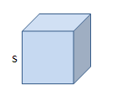

**Review of surface area of shapes**

If a solid is composed of flat surfaces, such as the cube below, the surface area is simply the sum of the areas of the flat surfaces (called faces). So, for example, if each edge of a cube has a length s, the area of one face is s2 since it is a square. Since by definition, a cube has six [congruent](https://www.mathopenref.com/congruent.html) faces, the total surface area is 6s2.

1. 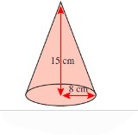Consider the shapes below.

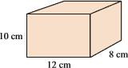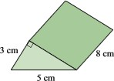

* 1. Name each shape.
  2. Find the total surface area of each shape.

1. Consider the hollow lampshade shown below:
2. Describe its shape.
3. How many faces does it have?
4. Calculate its total surface area.

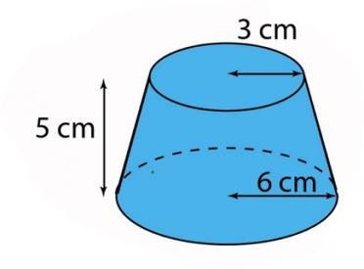

1. Consider the shape below:

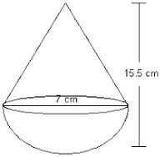

* 1. It’s made up of two shapes, name them.
  2. Calculate its total surface area.



**Coordinate geometry**

We have been looking at shapes and we discussed how shapes have points, lines, faces and vertices.

One way to specify the exact position of a points, lines and shapes is to use the two-dimensional number plane also called the **Cartesian plane** or the x-y axis.

The Cartesian plane has a point of reference called the origin. Through the origin, we draw two fixed lines, which are perpendicular to each other. The horizontal line is called the *x*-axis and the vertical line is called the *y*-axis.

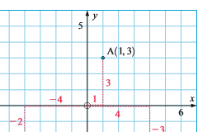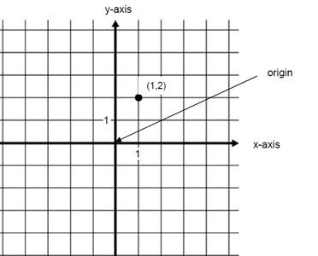

The 𝑥-axis is an ordinary number line with positive numbers to the right of O and negative numbers to the left of O.

Similarly, the *y*-axis has positive numbers above O and negative numbers below O.

Points on this plane are represented by an ordered pair of numbers in the form **(*x, y).***

To help us identify particular points, we refer to them using a capital letter followed by the ordered pair(*x, y*).

For example points A (1,3). To plot this point, we start at the origin and move 1 unit to the right and 3 units up as shown alongside.

##### Activity 2

1. a) Draw a Cartesian plane in your books, the *x*-axis and *y*-axis from -5 to +5.

b) Mark the following points in your Cartesian plane A(1,3), B(2,5), C(-2,3) D(-3,-4)

1. Draw a Cartesian plane from -5 to +5 on both axes.
   1. Mark the following points: A(-2,-4), B (-1,-2), C(1,2), D(2,4)
   2. Join these points using a ruler



Consider the equation *y*  *x* . This equation describes a relationship between 2 variables x and y.

For any given value of *x*, we can use the equation to find the value of *y*. For example

If *x*=2, then *y*=2 because *y=x*

If *x*=3, then *y*=3

##### Exercise 1

1. Using the equation *y*  *x* , complete the table of values below. The first 2 values have been filled out for you.

|  |  |  |  |  |  |
| --- | --- | --- | --- | --- | --- |
| 𝒙 | 2 | 3 |  |  |  |
| 𝒚 | 2 | 3 |  |  |  |

1. The values in the table can also be written as (2, 2), (3, 3). These are coordinates. Write out the rest of the values in coordinate form.
2. Draw a Cartesian plane and mark these points. Join them with a ruler. Notice that the points form a continuous straight line which can be extended on both sides.
3. a) Consider the equation

*y*  *x* 1, complete the following table

|  |  |  |  |  |  |
| --- | --- | --- | --- | --- | --- |
| 𝒙 | -1 | 0 | 1 | 2 | 3 |
| 𝒚 |  |  |  |  |  |

b) Plot the points on a Cartesian plane and join them to make a line.

1. Draw the line

*y*  2*x*  2 by first filling in a table of values

|  |  |  |  |  |  |
| --- | --- | --- | --- | --- | --- |
| 𝒙 |  |  |  |  |  |
| 𝒚 |  |  |  |  |  |

* 1. Compare the line the 𝑦 −axis?

*y*  2*x*  2 and

*y*  *x* 1, where do each of them cut

* 1. Which line is steeper?



**The equation of a line**

The equation of a line is an equation which connects the 𝑥 and 𝑦 coordinates of all points on a line.

***For example***

The equation *y*  *x* 1 connects the 𝑥 and 𝑦 values for every point on the line where the 𝑦 coordinate is 1 plus the 𝑥 coordinate.

This line crosses or cuts the 𝑦-axis at point 1. While the line with equation

*y*  2*x*  2 cuts the 𝑦-axis at point 2. These points are called the **y intercepts**

*y*  2*x*  2 is steeper than *y*  *x* 1 .

**Gradient**

**The gradient of a line is a measure of how steep the line is.**

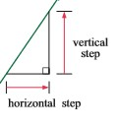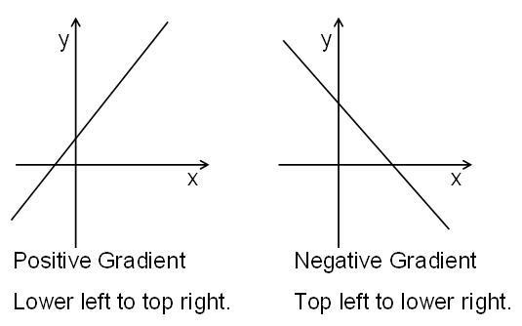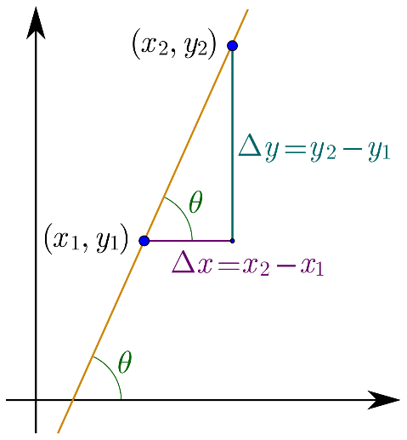

An increasing line has a positive gradient. A decreasing line has a negative gradient.

We measure the steepness by comparing the vertical step and the horizontal step

𝑣𝑒𝑟𝑡𝑖𝑐𝑎𝑙 𝑠𝑡𝑒𝑝

𝑔𝑟𝑎𝑑𝑖𝑒𝑛𝑡 = ℎ𝑜𝑟𝑖𝑧𝑜𝑛𝑡𝑎𝑙 𝑠𝑡𝑒𝑝

When using the Cartesian plane, the gradient is found by reading 2 coordinates on the line (𝑥2, 𝑦2) and (𝑥1, 𝑦1) and using the following formula

𝑔𝑟𝑎𝑑𝑖𝑒𝑛𝑡 = 𝑦2 − 𝑦1

𝑥2 − 𝑥1

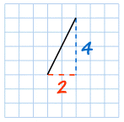

|  |
| --- |
| The Gradient = 4= 2  2 |
| The line is steeper, and so the Gradient is larger. |

|  |
| --- |
| The Gradient = 3= 0.6  5 |
| The line is less steep, and so the Gradient is smaller. |

##### gradient 3/5Exercise 2

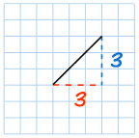

***Examples:***

The Gradient = 3 = 1

3

**So the Gradient is equal to 1**

1. Consider the line with equation *y*  *x*  2
   1. Fill the table of values below:

|  |  |  |  |
| --- | --- | --- | --- |
| 𝑥 |  |  |  |
| 𝑦 |  |  |  |

* 1. Draw the line on a Cartesian plane using the point in your table. Extend the line so that it cuts the 𝑦-axis. Where does it cut the 𝑦-axis? This point is called the 𝒚**-intercept.**
  2. Write down the coordinates of any 2 points on the line.
  3. Calculate the gradient of the line.
  4. What relationship can you notice from the equation of the line and the 𝑦

intercept and the gradient?

* 1. Without drawing the lines, write the value of the gradient and the

𝑦 intercept.

i)

ii)

* 1. iv)

*y*  *x*  3

*y*  3*x* 1

*y*  1 *x*  2

2

*y*  2*x*  3

## Proving Pythagoras’ theorem

##### Task: In pairs, talk about various proofs of Pythagoras’ theorem

There are literally hundreds of proofs of Pythagoras’ theorem, you will consider a few here:

##### Proof 1

Consider the following figures.

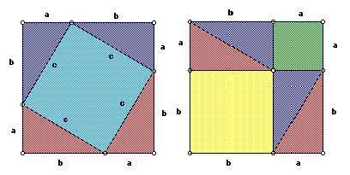

Derive an expression for the area of the square with side length c.

##### Proof 2

Consider the following figure.

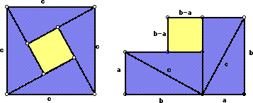

How does this help to prove Pythagoras’ theorem?

##### Proof 3

This proof starts with a right-angled triangle, ACB. A perpendicular (CE) is drawn from the right angle to the longest side (hypotenuse). Use the figure below to derive Pythagoras’ theorem.

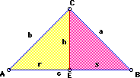

## The Unit Circle

##### Activity 4: To be done in groups. Each group to present their findings to the class.

*Tools needed for this task: Graph paper, pencil 0.5 mm lead thickness, ruler, protractor, a pair of compasses and a scientific calculator*

On a graph paper, draw *x* and *y* axes such that the origin (0, 0) is nearly in the centre of the paper and let the scale be 10 cm = 1 unit on both axes.

Using a pair of compasses, draw a circle of centre (0, 0) and radius = 1 unit (that is, 10 cm).

Point A is the point having coordinates (1, 0).

Point P moves anticlockwise on the circumference of the circle starting at point A (1, 0).

Let angle *θ* be the angle in degrees between OP and OA measured anti- clockwise.

For every value of the angle *θ* in the table below:

* Place point P such that the angle in degrees between OP and OA measured anti-clockwise = *θ.*
* Measure the *x* and *y* coordinates of point P. Example when *θ* = 240°.

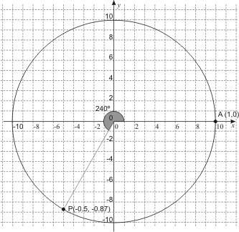

Copy and complete the table below. Keep increasing the value of *θ* by an increment of 15° until you complete one round and reach the value of 360°. Remember that 10 cm = 1 unit.

|  |  |  |
| --- | --- | --- |
| Angle *θ* in degrees between OP  and OA | The *x*-coordinate of point P | The *y*-coordinate of point P |
| 0 |  |  |
| 15 |  |  |
| 30 |  |  |
| 45 |  |  |
| 60 |  |  |
| 75 |  |  |
| 90 |  |  |
| 120 |  |  |
| . |  |  |
| . |
| . |
| 240 |  |  |
| . |  |  |
| . |
| . |
| 360 |  |  |

1. How many values do you actually need to measure?
2. Plot your *x*-values against 𝜃 and *y*-values against 𝜃 on separate graphs.

Generalize a statement describing the possible relation between the coordinates of point P and the values of sin *θ* and cos *θ*.

Use the general case in the diagram below to justify your statement above. These are the graphs of the trigonometric functions, sine and cosine.

This is the right-angled triangle you have been exploring. Which of your graphs is which?

sin 𝜃

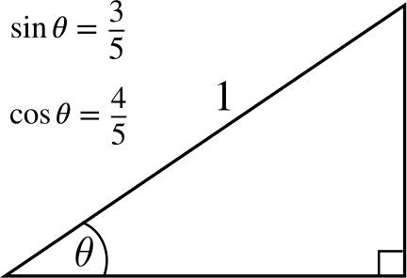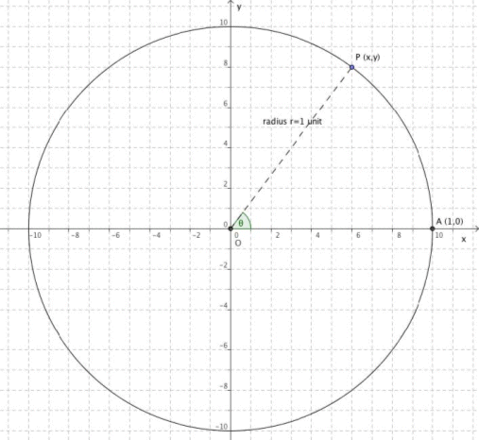

cos 𝜃

tan 𝜃

sin 𝜃

When a tangent to the circle is drawn at A and the line OP is extended to meet it, a similar triangle is created. The length of the tangent defines a new trigonometric function called tangent. Generalize a statement for tan *θ* in terms of sin *θ* and cos *θ*.

When the radius of the circle is r, our right-angled triangle can be scaled.

r sin 𝜃



𝑟

r cos 𝜃

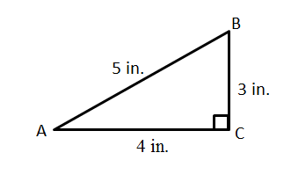

What do you notice about these values?

3

tan 𝐵 = 4

4

tan 𝐴 = 3

5

cos 𝐵 = 3

5

cos 𝐴 = 4

5

sin 𝐵 = 4

5

sin 𝐴 = 3

***Example***

State the value of the trigonometric functions for the right-angled triangle below.

##### Exercise 3

Find the following:

1. 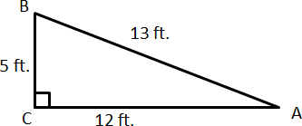Sin A
2. Cos A
3. Tan A
4. Sin B
5. Cos B
6. Tan B

**UNIT 3**

# ALGEBRA



**Algebraic expressions and equations**

Expansion

Consider the expression 2*x*  3. We say that 2 is the coefficient of the

expression in the brackets.

We expand the brackets by multiplying the coefficient by each term within the brackets and then adding the result.

Therefore, 2*x*  3  2*x*  6

This can be generalized as *a**b*  *c*  *ab*  *ac*

##### Exercise 1

1. Consider the rectangle shown below:

It has been sub divided into 2 smaller rectangles.

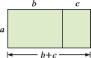

* 1. Find the area of the big rectangle.
  2. Find the area of the two smaller rectangles
  3. What do you notice?

1. Consider the rectangle below: Give an expression for the area of:

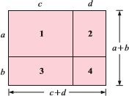

1. rectangle 1
2. rectangle 2
3. rectangle 3
4. rectangle 4
5. the overall rectangle What can you conclude?
6. Use you observations to expand:

a)  *x*  2 *x*  3

b) 2*x*  2*x*  3

1. *x*  2*x*  3
2. 2*x*  2*x*  3
3. Consider the rectangle below:

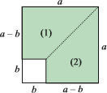

* 1. Find an expression for the area of the shaded part.
  2. Copy this rectangle on plain paper and cut it out. Cut along the dotted line and flip the two pieces to form another rectangle. What is the area of the new rectangle?

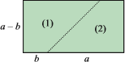

* 1. What conclusion can you make?

Using your observation, expand and simplify:

i) *x*  2*x*  2

1. 2*x*  22*x*  2
2. 5  *y*5  *y*
3. 5*x*  25*x*  2

What happens to the middle terms when simplifying?

1. 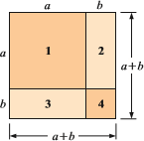Consider the square below:

Give an expression for the area of:

* 1. square 1
  2. rectangle 2
  3. rectangle 3
  4. square 4
  5. the overall square

Use your observation to expand and simplify:

* + 1. *x*  2(*x*  2)
    2. *x* 12
    3. (*x*  *y*)2
    4. (3*x*  2)2
    5. (2*x* 1)2
    6. 3  4*x*2

Your observations can be summarized as follows:

* + - 1. *a*  *b*(*c*  *d* )  *ac*  *ad*  *bc*  *bd*
      2. *a*  *b*2  *a*2  2*ab*  *b*2
      3. *a*  *b*2  *a*2  2*ab*  *b*2
      4. *a*  *b*(*a*  *b*)  *a*2  *b*2

The last three observations form quadratic expressions and are known as

##### quadratic identities



**Expansion**

When an expression is written as a product of its factors, it is said to have been **factorized.** For example 3*x* 15 can be written as 3(*x*  5) where the factors are 3 and (*x*  5) .

Notice that 3(*x*  5)  3*x* 15 so factorization is the reverse of expansion

**Exercise 2**

1. Fill in the gaps in the following statements
   1. (*x*  5)2  *x*2  *x* 
   2. *x*2 10*x*  25  (*x*  )2
   3. *x*2 10*x*  25  (*x*  )2
   4. *x*2  6*x*  9  (*x*  )2

#### (2*x*  3)2 

* 1. 4*x*2 12*x*  9  ( *x*  )2

1. Consider the following statements.
   1. *x*  2*x*  3  *x*2  3*x*  2*x*  6  *x*2  5*x*  6
   2. *x* 1*x*  2  *x*2  *x*  2*x*  2  *x*2  3*x*  2

What do you notice?

* 1. Using your observation, complete the following statements:

*x*2  5*x*  6  *x*  *x*  

*x*2  3*x*  2  *x*  *x*  

*x*2  (*a*  *b*)*x*  *ab*  *x*  *x*  

What relationship do you observe between the middle term, (a + b) and the constant term (ab) and the numbers in the brackets (𝑎 and 𝑏)?

This process of writing a quadratic expression in terms of its factors is called

##### factorization.

1. You should have observed that the middle term is the **sum** of the factors and the constant term is the **product** of the factors.

Use this observation to factorize the following:

1. *x*2 11*x* 18
2. *x*2 11*x*  24
3. *x*2 13*x*  36
4. *x*2  7*x* 12
5. *x*2 15*x*  54
6. a) Consider

factors is -2.

*x*2  *x*  2 , the sum of the factors is -1 and the product of the

Find two numbers which have product of -2 and sum of -1. Did you find -2 and 1?

So *x*2  *x*  2  *x*  2*x* 1

Verify this answer by expanding *x*  2*x*  1

1. Hence, factorise,
   1. *x*2  *x*  6
   2. *x*2  4*x*  45
   3. *x*2  7*x* 12
   4. *x*2  21*x* 100
2. Fully factorise the following by first removing a common factor
3. 3*x*2  6*x*  72
4. 2*x*2 18*x*  28
5. 5*x*2  20*x* 15



**Solving quadratic equations**

Consider *x*2  5*x*  6  0 , this is called a **quadratic equation** because it has an equal sign.

To solve a quadratic equation, we must first factorise the quadratic expression

*x*2  5*x*  6

*x*2  5*x*  6  *x*  3*x*  2

Therefore *x*2  5*x*  6  *x*  3*x*  2  0

**If the product of some numbers is zero, what can you say about the numbers?**

So, *x*  3*x*  2  0 , means that *x*  3  0 or *x*  2  0

Which means that *x*  3or *x*  2

##### Exercise 3

Solve the following quadratic equations.

1. 2*x*(*x*  2)  0
2. *x*  2*x*  2  0
3. *x*2  7*x* 10  0
4. *x*2  4*x*  0
5. *x*2 16  0
6. *x*2  5*x*  4  0
7. *x*2  3*x*  28
8. *x*2  2  3*x*

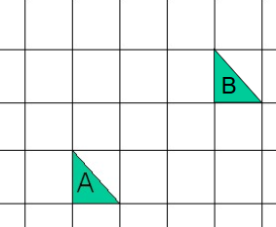

**Vectors**

**Review:** In book 1, we looked at translating a shape by a translation vector (𝒙)

𝒚

**Vector translation:**

Vectors can be used to translate objects on a grid. Consider triangle A in the diagram below.

Triangle A has been moved by translation vector  3  to triangle B

 

 2 

***Example***

**P'** (7, 2) is the image of **P** (2, 11) after a translation. What vector describes this translation?

***Solution***

Did you get ( 5 ) ?

−9

To work out the horizontal movement after the translation, subtract the 𝑥- coordinates for P from P':

7 - 2 = 5

To work out the vertical movement after the translation, subtract the 𝑦-coordinates for P from P':



2 - 11 = - 9

The vector that describes the translation is: ( 5 )

−9

If you are not sure, try drawing a sketch and marking the points **P** and **P'** on it. The shape has been translated 5 units to the right and 9 units downwards.

Remember that any move to the left or downwards needs a **-** sign.

**Position Vectors**

These are vectors which give the position of vectors relative to the origin on the Cartesian plane.

##### Exercise 4: To be done in groups

1. On a square grid, copy triangle A and B and

 4 

* 1. translate triangle B using  1 to get triangle C

 

* 1. What vector translates A onto C?

1. On square grid, copy the diagram below.

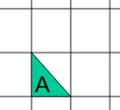

 5 

* 1. Translate triangle A with vector  2 to get triangle B

 

 5

* 1. Translate triangle B with vector 



 , where do you end up?

2 

1. On square grid mark points A(1,1), B(1, 3) and C( 3,1). Join to form triangle ABC.
2. Draw the triangle PQR the image of triangle ABC after a

translation with vector 3

( )

1

1. Draw triangle DEF, the image of triangle ABC after a translation

with vector 4

( )

##### Activity

0

1. Draw triangle GHI, the image of triangle ABC after a translation

with vector ( 0 )

−3

1. Use translation vectors to give direction from your classroom to the headmasters’ office
2. How can we apply vectors in real life? c)

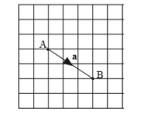

**Vector notation:** We denote vectors using boldface as in **a** or **b**. When writing by hand we usually underline i.e. a. We denote the magnitude of the

vector **a** by |𝐚| or a.

The two points A and B are shown in the diagram below. The displacement of B from A is a vector because it has length and a direction.

We`can write this displacement as

*AB*   3  or we can label the vector **a** and

 2 

 

write **a**   3 

 2 

 

##### Exercise 5: To be done in pairs

1. Given that

*a*   4  **,** *b*   3  **,** *c*   2  **.**

     

2

1

1

     

* 1. Draw the vectors
     1. *a*,*b*, *a*  *b*
     2. *a*, *c*, *a*  *c*
     3. ***b****,* ***c****,* ***b + c***

1. Consider the points A(2, 3) and B(1, 5).
   1. Draw a Cartesian plane on squared paper or graph paper and mark the points A and B
   2. Join Point A to the origin and put an arrow on the line segment OA going upwards. This represents the vector OA. Notice that the vector is moving upwards because we are starting our movement from A and ending at B.
   3. Join point B to the origin and mark the vector OB. Note that this vector will also move upwards since we are starting from O and moving to B.
   4. What is the column vector OA and OB?
2. Use the points in the grid below to write the vectors given in column vector form
   1. AB b) AC c) DE d) BE e) EB f) AD g) CD h) DC

What is the relationship between AC and CA

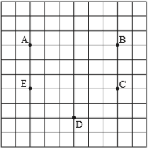

1. Consider the vectors

3 and 6

𝒂 = ( ) 𝒃 = ( )

2 4

1. Draw vectors **a** and **b** on a grid.
2. What relationship do they have? Express it in equation form?
3. Without drawing vector exists between **a** and **c.**

9

𝒄 = ( )

6

describe the relationship that



**Sets**

**What is a set?**

A set is a collection of objects. The objects in the set are called elements of the set. 𝐴 set is well-defined if there is a way to determine if an object belongs to the set or not. To indicate that we are considering a set, the objects (or the description) are put inside a pair of set braces, {}.

For example, the items you wear is a set: these include shoes, socks, hat, shirt, pants, and so on.

You write sets inside **curly brackets** like this:

**{socks, shoes, pants, watches, shirts, ...}**

You can also have sets of numbers: Set of whole numbers: {0, 1, 2, 3 ...}

Set of prime numbers: {2, 3, 5, 7, 11, 13, 17 ...}

##### Activity 1: Work in pairs.

Are the following sets well-defined?

1. The set of all groups of size three that can be selected from the members of this class.
2. The set of all books written by John Grisham.
3. The set of great rap artists.
4. The best fruits.
5. The 10 top-selling recording artists of 2017.



##### Equality

Two sets are equal if they contain exactly the same elements.

###### Example 1.

1. {1, 3, 4, 5} is equal to the set {5, 1, 4, 3}
2. The set containing the letters of the word railed is equal to the set containing the letters of the word redial.

There are two basic ways to describe a set. The first is by giving a description, as we did in Activity 1 and the second is by listing the elements as we did in Example 1 (1).

**Notation:** We usually use an upper case letter to represent a set and a lower case

𝑥 to represent a generic element of a set. The symbol ∈ is used to replace the words “is an element of”; the expression 𝑥 ∈ 𝐴 would be read as 𝑥 is an element of 𝐴. If two sets are equal, we use the usual equal sign: 𝐴 = 𝐵.

###### Example 2.

𝐴 = {1, 2, 3, 5}

𝐵 = {𝑚, 𝑜, 𝑎, 𝑛}

𝐶 = {𝑥: 𝑥 ≥ 3 𝑎𝑛𝑑 𝑥 ∈ 𝑅}

𝐷 = {𝑝𝑒𝑟𝑠𝑜𝑛𝑠 ∶ 𝑡ℎ𝑒 𝑝𝑒𝑟𝑠𝑜𝑛 𝑖𝑠 𝑎 𝑟𝑒𝑔𝑖𝑠𝑡𝑒𝑟𝑒𝑑 𝐷𝑒𝑚𝑜𝑐𝑟𝑎𝑡}

𝑈 = {𝑐𝑜𝑢𝑛𝑡𝑟𝑖𝑒𝑠 ∶ 𝑡ℎ𝑒 𝑐𝑜𝑢𝑛𝑡𝑟𝑦 𝑖𝑠 𝑎 𝑚𝑒𝑚𝑏𝑒𝑟 𝑜𝑓 𝑡ℎ𝑒 𝑈𝑛𝑖𝑡𝑒𝑑 𝑁𝑎𝑡𝑖𝑜𝑛𝑠}

##### The Universal Set

In order to work with sets we need to define a Universal Set, 𝑈, which contains all possible elements of any set we wish to consider. The Universal Set is often obvious from context but on occasion needs to be explicitly stated.

For example, if we are counting objects, the Universal Set would be whole numbers. If we are spelling words, the Universal Set would be letters of the alphabet. If we are considering students enrolled in Juba University math classes this semester, the Universal Set could be all Juba University students enrolled



this semester or it could be all Juba University students enrolled from 2000 to 2005. In this last case, the Universal Set is not so obvious and should be clearly stated.

**The Empty Set**

On occasion it may turn out that a set has no elements, the set is empty. Such a set is called the empty set and the notation for the empty set is either the symbol

∅ or a set of braces alone, {}.

***Example 3.***

Suppose 𝐴 is the set of all integers greater than 3 and less than −1. What are the elements of 𝐴? There are no numbers that meet this condition, so 𝐴 = ∅.

**Subset.** 𝐴 is a subset of 𝐵 if every element that is in 𝐴 is also in 𝐵. The notation for 𝐴 is a subset of 𝐵 is 𝐴 ⊆ 𝐵. Note: 𝐴 and 𝐵 can be equal.

##### Activity 2: Work in pairs.

𝐴 = {0, 1, 2, 3, 4, 5}

𝐵 = {1, 3, 4}

𝐶 = {6, 4, 3, 1}

𝐷 = {0, 1, 2, 5, 3, 4}

𝐸 = {}

Which of the sets 𝐵, 𝐶, 𝐷, 𝐸 are subsets of 𝐴? Discuss with your partner.

**Complement.** Every set is a subset of some universal set. If 𝐴 ⊆ 𝑈 then the complement of 𝐴 is the set of all elements in 𝑈 that are NOT in 𝐴. This is denoted: 𝐴. Note that 𝐴 = 𝐴, i.e. the complement of the complement is the original set.

***Example 4.***

Consider the same sets as in ***Example 3***. It appears that the set of all integers,

𝑈 = {0, 1, 2, 3, 4, 5, 6, 7, 8, 9}, would be a natural choice for the univere in this case. So, we would have



𝐴 = {6, 7, 8, 9}

𝐵 = {0, 2, 5, 6, 7, 8, 9}

𝐶 = {0, 2, 5, 7, 8, 9}

𝐸 = 𝑈

##### Activity 3: To be done in groups

Let A be the set of all numbers from 1 to 20, then A= {1, 2, 3, 4, 5, 6 ….20}

1. Write down the number of elements of A
2. Let B be the set of all odd numbers from 1 to 20, write down the set B. How many elements does B have?
3. Are the following statements true?
   1. B  A
   2. 5B
   3. n(A) = 9

##### Activity 4: To be discussed in groups

1. From the example above find
   1. A B
   2. A B
   3. B’
2. If U = {-3, -2, -1, 0, 1, 2, 3}, A ={-2, 0, 2, 3} and B={-3, -2, 1, 3}
   1. List the elements of
      1. 𝐴’
      2. 𝐵’
      3. A  B
      4. A B
      5. A  B’
      6. ) A’  B’

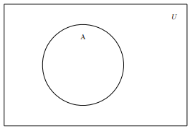

* 1. Find n(A’ B’)

1. For U = {2, 3, 4, 5, 6, 7} and B={2,5,7}
   1. list the set B’
   2. show that B B’= Ø and that B B’=U
   3. Show that *n(B) + n(B’) = n(U)*
2. Suppose U ={0,1,2,3,4,5… ,20}, F={factors of 24} and M= {multiples of

4}

* 1. List the sets:
     1. F ii) M iii) M’ iv) F M v)F  M’ vi) F M
  2. Find n(F M’)

**Venn diagrams**

Pictures are your friends! It is often easier to understand relationships if we have something visual. For sets we use Venn diagrams. A Venn diagram is a drawing in which there is a rectangle to represent the universe and closed figures (usually circles) inside the rectangle to represent sets.

One way to use the diagram is to place the elements in the diagram. To do this, we write/draw those items that are in the set inside of the circle. Those items in the universe that are not in the set go outside of the circle.

***Example 5.***

With the sets 𝑈 = {𝑟𝑒𝑑, 𝑜𝑟𝑎𝑛𝑔𝑒, 𝑦𝑒𝑙𝑙𝑜𝑤, 𝑔𝑟𝑒𝑒𝑛, 𝑏𝑙𝑢𝑒, 𝑖𝑛𝑑𝑖𝑔𝑜, 𝑣𝑖𝑜𝑙𝑒𝑡} and

𝐴 = {𝑟𝑒𝑑, 𝑦𝑒𝑙𝑙𝑜𝑤, 𝑏𝑙𝑢𝑒}, the diagram looks like

47

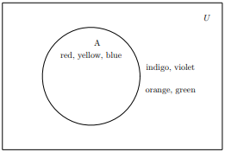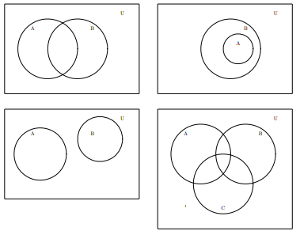

Notice that you can see 𝐴′ as well. Everything in the universe not in 𝐴,

𝐴′ ={orange, indigo, violet, green}.

If there are more sets, there are more circles, some pictures with more sets follow.

##### Set Operations

The first operation we will consider is called the union of sets. This is the set that we get when we combine the elements of two sets. The union of two sets, 𝐴 and

𝐵 is the set containing all elements of both 𝐴 and 𝐵; the notation for 𝐴 union 𝐵 is

𝐴 ∪ 𝐵. So if x is an element of 𝐴 or of 𝐵 or of both, then 𝑥 is an element of 𝐴 ∪

𝐵.

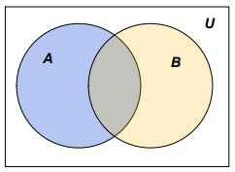

###### Example 6

For the sets 𝐴 = {𝑏𝑒𝑎𝑟, 𝑐𝑎𝑚𝑒𝑙, ℎ𝑜𝑟𝑠𝑒, 𝑑𝑜𝑔, 𝑐𝑎𝑡} and 𝐵 =

{𝑙𝑖𝑜𝑛, 𝑒𝑙𝑒𝑝ℎ𝑎𝑛𝑡, ℎ𝑜𝑟𝑠𝑒, 𝑑𝑜𝑔}, we would get 𝐴 ∪ 𝐵 =

{𝑏𝑒𝑎𝑟, 𝑐𝑎𝑚𝑒𝑙, ℎ𝑜𝑟𝑠𝑒, 𝑑𝑜𝑔, 𝑐𝑎𝑡, 𝑙𝑖𝑜𝑛, 𝑒𝑙𝑒𝑝ℎ𝑎𝑛𝑡}.

To see this using a Venn diagram, we would give each set a color. Then A ∪ B would be anything in the diagram with any color.

*Note:* 𝐴 ∪ 𝐴̅ = 𝑈, the union of a set with its complement gives the universal set.

###### Example 7

If we color the set 𝐴 with blue and the set 𝐵 with orange, we see the set 𝐴 ∪ 𝐵 as the parts of the diagram that have any color (blue, beige, orange).

The next operation that we will consider is called the intersection of sets. This is the set that we get when we look at elements that the two sets have in common. The intersection of two sets, 𝐴 and 𝐵 is the set containing all elements that are in both 𝐴 and 𝐵; the notation for 𝐴 intersect 𝐵 is 𝐴 ∩ 𝐵. So, if 𝑋 is an element of

𝐴 and 𝑥 is an element of 𝐵, then x is an element of 𝐴 ∩ 𝐵.

###### Example 8.

For the sets 𝐴 = {𝑏𝑒𝑎𝑟, 𝑐𝑎𝑚𝑒𝑙, ℎ𝑜𝑟𝑠𝑒, 𝑑𝑜𝑔, 𝑐𝑎𝑡} and 𝐵 =

{𝑙𝑖𝑜𝑛, 𝑒𝑙𝑒𝑝ℎ𝑎𝑛𝑡, ℎ𝑜𝑟𝑠𝑒, 𝑑𝑜𝑔}, we would get 𝐴 ∩ 𝐵 = {ℎ𝑜𝑟𝑠𝑒, 𝑑𝑜𝑔}.

To see this using a Venn diagram, we would give each set a color. Then 𝐴 ∩ 𝐵

would be anything in the diagram with both colors.

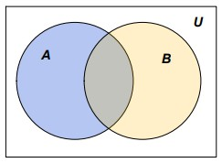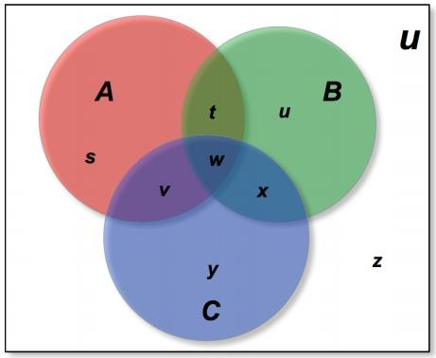

###### Example 9

If we color the set 𝐴 with blue and the set 𝐵 with orange, we see the set 𝐴 ∩ 𝐵 as the part of the diagram that has both blue and orange resulting in a beige colored ”football” shape.

*Note*: 𝐴 ∩ 𝐴̅ = {}, the intersection of a set with its complement is the empty set.

We can extend these ideas to more than two sets. With three sets, the Venn diagram would look like

In this diagram, the three sets create several “pieces” when they intersect. I have given each piece a lower case letter while the three sets are labelled with the

upper case letters 𝐴, 𝐵, and 𝐶. I will describe each of the pieces in terms of the sets 𝐴, 𝐵, and 𝐶.



With three sets, the keys to completing the Venn diagrams are the “triangle” pieces, 𝑡, 𝑣, 𝑤, and 𝑥. The darkest blue piece in the center, w, is the intersection of all three sets, so it is A ∪ B ∪ C; that is the elements in common to all three sets, 𝐴 and 𝐵 and 𝐶. The yellow piece 𝑡 is part of the intersection of 2 of the sets, it is the elements that are in both 𝐴 and 𝐵 but not in 𝐶, so it is 𝐴 ∩ 𝐵 ∩ 𝐶.

Similarly 𝑣, the purple piece, is the elements that are in both 𝐴 and 𝐶 but not in

𝐵, 𝐴 ∩ 𝐶 ∩ 𝐵. Finally, the blue piece 𝑥 is the elements that are in both 𝐵 and 𝐶

but not in 𝐴, 𝐴 ∩ 𝐵 ∩ 𝐶.

The next pieces to consider are the football shaped pieces formed by joining two of the triangle pieces. The piece composed of 𝑡 and 𝑤 is the elements in both 𝐴 and 𝐵, so it is the set 𝐴 ∩ 𝐵. The football formed by v and w is the elements that are in both 𝐴 and 𝐶, that is 𝐴 ∩ 𝐶. The last football, formed by 𝑥 and 𝑤, is the elements in both 𝐵 and C, i.e. 𝐵 ∩ 𝐶.

The areas to consider are the large outer pieces of each circle. The red region marked with 𝑠 is the elements that are in 𝐴 but not in 𝐵 or 𝐶, this is the set 𝐴 ∩ (̅̅𝐵̅̅̅∪̅̅̅̅𝐶̅̅). Similarly, the green region, 𝑢 is the elements that are in 𝐵 but not in

𝐴 or 𝐶, i.e. 𝐵 ∩ (̅̅𝐴̅̅̅∪̅̅̅̅𝐶̅̅). Lastly, the blue region marked with y is the elements that are in 𝐶 but not in 𝐴 of 𝐵, the set 𝐶 ∩ (̅̅𝐴̅̅̅∪̅̅̅𝐵̅̅̅).

The final region, 𝑧, outside of all the circles is the elements that are not in 𝐴 nor in 𝐵 nor in 𝐶. It is the set (̅̅𝐴̅̅̅∪̅̅̅̅𝐵̅̅̅∪̅̅̅̅𝐶̅̅).

We will return to these ideas with a later example, but first we need a few more ideas.

##### Applications.

In this section, we will illustrate the use of Venn diagrams in some examples.

##### Task: Work in groups

Two programs were broadcast on television at the same time; one was the Big Game and the other was Ice Stars. The Nelson Ratings Company uses boxes

attached to television sets to determine what shows are actually being watched. In its survey of 1000 homes at the midpoint of the broadcasts, their equipment showed that 153 households were watching both shows, 736 were watching the Big Game and 55 households were not watching either.

1. Draw a Venn diagram.
2. How many households were watching only Ice Stars?
3. What percentage of the households were not watching either broadcast?

##### Task: Work in groups.

In a recent survey people were asked if they took a vacation in the summer, winter, or spring in the past year. The results were 73 took a vacation in the summer, 51 took a vacation in the winter, 27 took a vacation in the spring, and 2 had taken no vacation. Also, 10 had taken vacations at all three times, 33 had taken both a summer and a winter vacation, 18 had taken only a winter vacation, and 5 had taken both a summer and spring but not a winter vacation.

1. Draw a Venn diagram.
2. How many people were surveyed?
3. How many people took vacations at exactly two times of the year?
4. How many people took vacations during at most one time of the year?
5. What percentage took vacations during both summer and winter but not spring?

##### Exercise 6: To be discussed in groups and answered individually

1. Consider the universal set U={0, 1, 2, 3, 4, 5, 6, 7, 8, 9}. Illustrate on a Venn diagram the sets:
   1. A = {2, 3, 5, 7} and B = {1, 2, 4, 6, 7, 8}
   2. A = {2, 3, 5,7} and B = {4, 6, 8, 9}
   3. A = {3, 4, 5, 6, 7, 8} and B = {4, 6, 8}
   4. A = {0, 1, 3, 7} and B = {0, 1, 2, 3, 6, 7, 9}
2. a) Come up with your own universal set
3. From this set create 2 others set A and B. List the elements of A and B. 9 Make sure some values are shared by A and B)
4. Draw Venn diagrams and shade regions represented by
   1. A B
   2. A B
5. List
   1. A B
   2. A B
6. In a form 3 class of 42 students, 25 study History, 19 study Geography and 10 study both History and Geography.
   1. Draw a Venn diagram.
   2. Find the number of students who study only History, n(H)
   3. Find the number who study only Geography, n(G)
   4. Find the number of students who do not study History or Geography, n(H G)’
7. In a class of 30 students, 7 have black hair and 24 are right handed. If 2 students neither have black hair nor are they right handed, how many students:
   1. have both black hair and are right handed.
   2. have black hair but are not right handed?
8. 46% of people in a town ride a bicycle and 45% ride a motor bike. 16% ride neither a bicycle nor a motor bike.
   1. Illustrate this information on a Venn diagram
   2. How many people ride:
      1. both a bicycle and a motor bike
      2. either a bicycle or a motor bike or both

iv) a bicycle only

## Matrices

A matrix is a rectangular arrangement of numbers arranged in **rows** and

##### columns.

###### Example

Garang has invested in real estate. He owns a block of 10 apartments, 5 double units and 3 stand-alone houses. He wishes to put new furniture in each of them.

In each apartment he puts 4 chairs, 1 table and 2 beds. In each double unit, he puts 6 chairs, 1 table and 3 beds In each house he puts 8 chairs, 2 tables and 4 beds.

One way to organize this information is use a table as follows:

|  |  |  |  |
| --- | --- | --- | --- |
|  | Chair | Table | Bed |
| Apartment | 40 | 10 | 20 |
| Unit | 30 | 5 | 15 |
| House | 24 | 6 | 12 |

This table is summarized in the following matrix:

 40 10



 30 5

 24 6



20 



15 

12 



This matrix has 3 columns and 3 rows so it is called a matrix of order 3 × 3

An *m*  *n* matrix has m rows and n columns

The numbers in the matrix are called its elements

*m*  *n* is called the **order** of the matrix. We often use capital letters to denote matrices.

 1  3 1 

For example

*A*  

 and

*B*  

0

−  , A is order 2 × 1 and B is order 2 × 2

 2  1



##### Discussion

1. Why do we state the rows first, then columns when we specify the matrix size?
2. What is the usefulness of organizing data in matrix form?
3. Collect data that can be arranged in matrix form. Arrange it and state the size of the matrix formed.



Equality of matrices:

Two matrices are equal if

* The matrices have the same number of rows and columns, and
* Elements in corresponding positions are equal.

If  *a*



 *c*

*d*   3 5

*b*    2

  1 , then *a*  2,*b*  1, *c*  3, *d*  5



Addition and subtraction of matrices

Two matrices can be added or subtracted only if they are of the same size. We **add/subtract corresponding elements**

***Example:***

 2 5   2 1  4 6

 1 1  3 5  4 4

Properties of matrix addition:

*A*  *B*  *B*  *A* : Matrix addition is commutative

*A*  (*B*  *C*)  ( *A*  *B*)  *C* : Matrix addition is associative



     



##### Exercise 8

A restaurant served 72 men, 84 women and 49 children on Friday night. On Saturday night they served 86 men, 72 women and 46 children.

* 1. Express this information in two column matrices.
  2. Use matrices to find the totals of men, women and children served over the two day period.





Note that the leading diagonal is the diagonal that moves downwards from left to right.



0

1 

0

0

1

0



 0

 **or**  0

 0 1



 1 0

**e.g.** 

 1



  

   



 2 11 2 (2  3)  (11) (2  2)  (1 2)  7 6

Not all matrices can be multiplied. Matrices A and B can only be multiplied if the number of columns in A equals the number of rows in B.

*Identity matrix*

*An identity matrix is a matrix which has 1’s in the leading diagonal and 0’s in the other positions.*

Matrix Multiplication

Matrix multiplication has a different meaning to that used for multiplying numbers. In this case we multiply each element of a row by the corresponding element of a column and then add the results.

For example,

 1 23 2  1 3 2 1 (1 2)  2  2  5 6



6 

 2





− 2 , 2*A*   4  4

 1 3 



Consider *A*   2

Scalar Multiplication

We multiply matrices with scalars just like we do with vectors.

##### Exercise 9

 2 4

 2 3

1. Consider the matrix

*A*  

3

 and *B*  

1  5

 the identity matrix

2

1 0

*I*   

 0 1

   

a) Evaluate *AB* , *AI* , *BI ABI* , *BA*

##### What do you observe? Discuss

1. **Given that**

1

* 1. *A*  

1

1 

 and

2

 2

*B*  1



− 1

 ,

1 

 7 4  3  4





* 1. ​

*A*  

 5

 and

3

*B*   5 7 

Evaluate *AB* . What do you notice?

What observation can you make about the elements in the diagonals of A and B?

*When two matrices A and B are such that B and vice versa.*

*AB*  *I then A is said to the inverse of*



**Determinant of a matrix**

Determinant of a 2×2 matrix helps us get the inverse of the matrix. We get the determinant by subtracting the product of the elements of the other diagonal from the product of the elements of the leading diagonal.

Consider *A*   *a*

 *c*  then

 *b d* 



determinant = ad - bc

What is determinant of the matrices in the exercise above? What is the determinant of the matrix below?

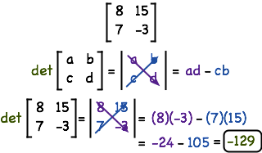

**Inverse of a 2**×**2 matrix**  *a*

**Where det= ad-bc**



*b* 

 *c d* 

 **is given by** 1  *d*

− *b* 

det  *c*





*a* 

What do you notice?

What do you observe about the elements of A and B?



3 

6  , evaluate *AB*

1 



 3

  2

 5  1



Consider *B*  6

1

 4 5

 

*A*   2

##### Exercise 10

Find the inverse of the following matrices:

 7 9 

 6 13 

5 10

1. *B*   





 3 4

1. *A*   2

− 4

1. *C*   

5 9 

## Solving simultaneous equations using matrices

##### Investigation: To be done in groups

* 1. Consider the following equations

3*x*  *y*  7 5*x*  2 *y*  12

 3 1  *x*   7 

* + 1. The above equations can be written as       .This is a

5

matrix equation. Discuss how this is done.

2 *y* 

12 

 3 1   7 

* + 1. The first matrix 

5

 is called the **coefficient**s matrix while   is

2 12

   

called the **constant**s matrix. Find the inverse of the coefficients matrix.

* + 1. Pre-multiply the inverse on both sides of the matrix equation. What happens?
    2. What are the values of *x* and *y*?
  1. Use the method above to solve the following equations:

3*x*  *y*  8

1. 2*x*  *y*  3

*x*  3*y*  5

1. 2*x*  6 *y*  7

3*y*  2*x*  3

1. 3*y*  *x*  4

Use substitution to check your answers.

##### Task

The diagram shows the graphs of various linear functions. Match the graphs with their equations.

1. Identify graphs that have the same *y*-intercept. Write down their equations. What do you notice?
2. Identify graphs that are parallel. Write down their equations. What do you notice?

𝑦 = 𝑥 + 4

**Equations**

𝑦 = 𝑥

𝑦 = 𝑥 − 2

𝑦 = 2𝑥 − 4

𝑦 = −𝑥

𝑦 = 2𝑥 + 6

𝑦 = −4𝑥 + 2 1

𝑦 = − 𝑥 + 1

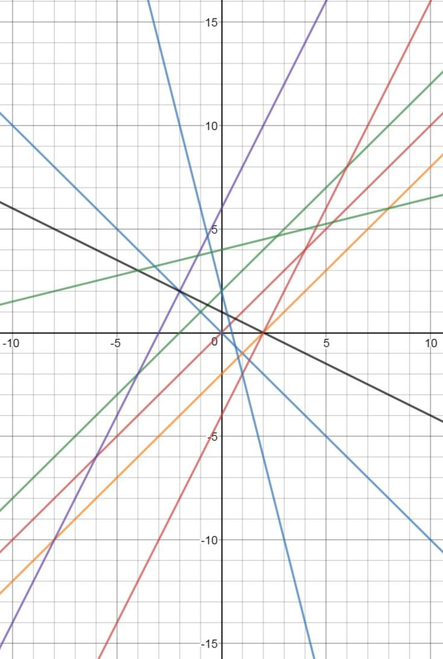

2

4

𝑦 = 𝑥 + 2 1

1. Identify graphs that are perpendicular. Write down their equations. What do you notice?

##### Exercise 11

1. Write down the equation of a line that is parallel to 𝑦 = 3𝑥 − 4
2. Write down the equation of a line that is perpendicular to 𝑦 = 3𝑥 − 4
3. Write down the equation of the line that is a reflection of 𝑦 = 3𝑥 − 4 in the *y*-axis
4. Write down the equation of the line that is a reflection of 𝑦 = 3𝑥 − 4 in the *x*-axis
5. Repeat 1-4 for an equation of your own.

## Functions

A **function** is a relation in which each element of the domain is paired with *exactly one* element of the range. The **domain** are x values while the **range** are the y values.

For a relation to be defined as a function, there is only one value of *y* for each element of *x*.

Another way of saying it is that there is one and only one output (*y*) with each input (*x*).

𝑦 = 2𝑥 + 5 is an example of a linear function. When plotted, it forms a straight line.

##### Function notation

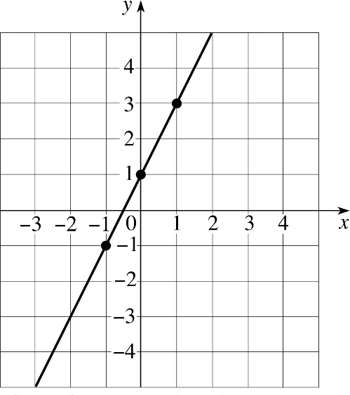

###### For example

61

*y*  *f* *x*

1. Determine whether each relation is a function.
   1. {(2, 3), (3, 0), (5, 2), (4, 3)}
   2. {(4, 1), (5, 2), (5, 3), (6, 6), (1, 9)}

Notice that in (a), each value of *y* has a different value of *x*, while in (b) when *x*=5, there are two different vales of *y*. *y*=2 and *y*=3. Therefore (a) is a function while (b) is not a function.

1. Given 𝑓(𝑥) = 3𝑥 − 2, find

i) *f*(3) ii) *f*(-2)

###### Solution:

*f* 3  3(3)  2  7 ,

*f*  2  3(2)  2  8

##### Exercise 12

* 1. Given that *h*(*x*)  *x*2  4*x*  9 , find i) h(-3) ii) h(2)
  2. Given that

*g*(*x*)  *x*2  2 , find g(4)

* 1. Given that 𝑓(𝑥) = 4𝑥 − 6 𝑔(𝑥) = 2𝑥2 − 𝑥

ℎ(𝑥) = (𝑥−6)2

2

Find

1. 5𝑓(−4) ii) ℎ(10) iii) ℎ(3) iv) 𝑔(−3) iv) 2ℎ(7)



**Composite functions**

**What are Composite Functions?**

Composition of functions is when one function is inside of another function. For example, if we look at the function ℎ(𝑥) = (2𝑥 – 1) 2. ℎ(𝑥) is formed by the composition of two functions. Firstly *x* is doubled and one is subtracted i.e*.*

𝑓(𝑥) = 2𝑥 – 1, then the output is squared ie. 𝑔(𝑥) = 𝑥2

We write: ℎ(𝑥) = 𝑔(𝑓(𝑥)).

The order of composition of functions natters. In this case f𝑓(𝑔(𝑥)) = 2𝑥2 − 1

##### Activity 1: Work in groups

Explore why it is important to pay attention to the order in which the composition of a function is written.

##### Activity 2: Work in groups.

How do you find the composition of two functions?



***Example***

Given that 𝑓(𝑥) = 5𝑥 + 10

Find: 𝑓(𝑔(2))

***Solution***

Find 𝑔(2) = 3(22) = 12

Find 𝑓(12) = 5(12) + 10 = 70

𝑔(𝑥) = 3𝑥2 ℎ(𝑥) = (𝑥 − 1)2



multiplication and subtraction. A little farther down the page we will find the

**Inverse functions**

**What is an Inverse Function?**

An inverse function is a function that will “undo” anything that the original function does. For example, we all have a way of tying our shoes, and how we tie our shoes could be called a function. So, what would be the inverse function of tying our shoes? The inverse function would be “untying” our shoes, because “untying” our shoes will “undo” the original function of tying our shoes.

Let’s look at an inverse function from a mathematical point of view.

Consider the function 𝑓(𝑥) = 2𝑥 – 5. If we take any value of 𝑥 and plug it into

𝑓(𝑥) what would happen to that value of 𝑥? First, the value of 𝑥 would get multiplied by 2 and then we would subtract 5. The two mathematical operations that are taking place in the function 𝑓(𝑥) are multiplication and subtraction. Now let’s consider the inverse function. What two mathematical operations would be needed to “undo” 𝑓(𝑥)? Division and addition would be needed to “undo” the



inverse of 𝑓(𝑥) = 2𝑥 – 5, and hopefully the inverse function will contain both division and addition.

**Notation**

If 𝑓(𝑥) represents a function, then the notation 𝑓−1 (𝑥), read “f inverse of x”, will be used to denote the inverse of 𝑓(𝑥). Similarly, the notation g-1 (x), read “g inverse of x”, will be used to denote the inverse of 𝑔(𝑥).

**Note**: f - 1 (𝑥) ≠ 1 . It is very important not to confuse function notation with

𝑓(𝑥)

negative exponents.

##### Activity 3: Work in groups.

* 1. Explain the difference in meaning of the notation 𝑓(2) = 5 versus the notation 𝑓−1(5) = 2
  2. Suppose the point (10, 5) lies on a graph of a function 𝑓, what point lies on the graph 𝑓−1.
  3. The number of people in thousands in a city is given by the function

𝑓(𝑡) = 20 + 0.4𝑡 where 𝑡 is the number of years since 1970.

* + 1. In the context of this problem, explain what 𝑓(25) and 𝑓−1(25) mean (no calculation required).

What is the unit measure (number of people or number of years) for f(25) and 𝑓−1(25)

* + 1. Now calculate 𝑓−1(25)
  1. The total cost, 𝐶, in South Sudanese pounds (SSP) for a clothing factory to make a number of jackets (*j)* is given by the function 𝐶 = 𝑓(𝑗). Interpret the meaning of the following notation within the context of the story given.
     1. 𝑓(30) = 678
     2. 𝑓−1(30) = 678

##### Does the Function have an Inverse?

64

Not all functions have an inverse, so it is important to determine whether or not a function has an inverse before we try and find the inverse.

So how do we know if a function has an inverse? To determine if a function has an inverse function, we need to talk about a special type of function called a **One-to-one Function**. A one-to-one function is a function where each input

(*x*-value) has a unique output (*y*-value). To put it another way, every time we plug in a value of *x* we will get a unique value of y, the same *y*-value will never appear more than once. A one-to-one function is special because only one-to-one functions have an inverse function.

Now let’s look at a few examples to help demonstrate what a one-to-one function is.

***Example 1***: Determine if the function f = {(7, 3), (8, –5), (–2, 11), (–6, 4)} is a one-to-one function.

The function f is a one-to-one function because each of the *y*-values in the ordered pairs is unique; none of the *y*-values appear more than once. Since the function f is a one-to-one function, the function f must have an inverse.

***Example 2***: Determine if the function h = {(–3, 8), (–11, –9), (5, 4), (6, –9)} is a one-to-one function.

The function h is not a one-to-one function because the 𝑦-value of –9 is not unique; the 𝑦-value of –9 appears more than once. Since the function h is not a one-to-one function, the function h does not have an inverse.

Remember that only one-to-one function have an inverse.

##### Is the Function a One-to-one Function?

We can determine if functions are one-to-one by looking at ordered pairs and determining if each of the 𝑦-values is unique, but what if we do not have ordered pairs? We could create ordered pairs by plugging different *x*-values into the function and finding the corresponding *y*-values giving us some ordered pairs.

Rather than spending time creating ordered pairs, why not consider looking at the entire graph of the function instead? By looking at the entire graph rather than a few points, we should still be able to determine if the function is a one-to- one function or not.

##### Activity 4: Work in groups.

Explore how you can determine if a function is a one-to-one function or not.

Now let’s look at a few examples to help explain the Horizontal Line Test.

***Example 3***: Determine if the function

𝑓(𝑥) =

3 𝑥 + 2

4

as a one-to-one function.

To determine if 𝑓(𝑥) is a one-to-one function, we need to look at the graph of

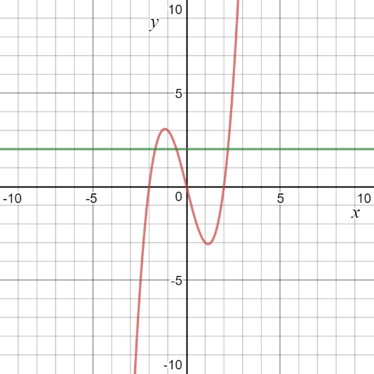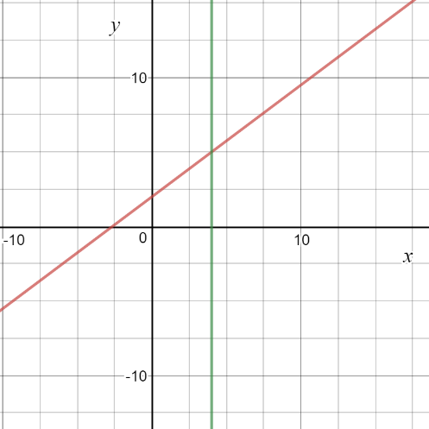

𝑓(𝑥). Since 𝑓(𝑥) is a linear equation the graph of 𝑓(𝑥) is a line with a slope of –

3and a y-intercept of (0, 2).

4

In looking at the graph, you can see that any horizontal line (shown in green) drawn on the graph will intersect the graph of 𝑓(𝑥) only once.

Therefore, 𝑓(𝑥) is a one-to-one function and 𝑓(𝑥) must have an inverse.

***Example 4***: Determine if the function 𝑔(𝑥) = 𝑥3 – 4𝑥 is a one-to-one function.

To determine if 𝑔(𝑥) is a one-to-one function, we need to look at the graph of

𝑔(𝑥).

In looking at the graph, you can see that the horizontal line (shown in green) drawn on the graph intersects the graph of 𝑔(𝑥) more than once.

Therefore, 𝑔(𝑥) is not a one-to-one function and 𝑔(𝑥) does not have an inverse.

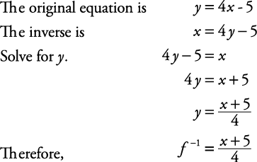

##### How to Find the Inverse Function

Now that we have discussed what an inverse function is, the notation used to represent inverse functions, one-to-one functions, and the Horizontal Line Test, we are ready to try and find an inverse function.

Here are the steps required to find the inverse function:

Step 1: Determine if the function has an inverse. Is the function a one-to-one function? If the function is a one-to-one function, go to step 2. If the function is not a one-to-one function, then say that the function does not have an inverse and stop.

Step 2: Change 𝑓(𝑥) to 𝑦. Step 3: Switch 𝑥 and 𝑦.

Step 4: Solve for 𝑦.

Step 5: Change 𝑦 back to f -1 ( 𝑥 ).

By following these 5 steps we can find the inverse function. Make sure that you follow all 5 steps. Many people will skip step 1 and just assume that the function has an inverse; however, not every function has an inverse, because not every function is a one-to-one function. Only functions that pass the Horizontal Line Test are one-to-one functions and only one-to-one functions have an inverse.

***Example***

##### Exercise 13

Solve:

1. 𝑓(𝑥) = 2𝑥+3

5

1. 𝑓(𝑥) = 2𝑥+3

2

find 𝑓−1(𝑥)

find 𝑓−1(𝑥)

1. The given coordinates are on 𝑓(𝑥), find the coordinates for 𝑓−1(𝑥).
   1. ( - 2, 4 )
   2. ( 4, 7 )
   3. ( 0, 11 )
   4. ( - 3, - 8 )
   5. ( 10, 10 )

**UNIT 4**

# STATISTICS

## Mean, Mode and Median



We will begin this unit by reviewing our work on **measures of central tendency**.

##### Measure of central tendency

There are three most common measures of central tendency, **the mean, mode and median**

**The mean:** The **mean** or **average** is the total of all data values divided by the number of data values. If all the data has the same value it will be the mean, since the total of the data is distributed equally across the number of pieces of data.

𝒔𝒖𝒎 𝒐𝒇 𝒅𝒂𝒕𝒂 𝒗𝒂𝒍𝒖𝒆𝒔

𝒎𝒆𝒂𝒏 = 𝒏𝒖𝒎𝒃𝒆𝒓 𝒐𝒇 𝒅𝒂𝒕𝒂 𝒗𝒂𝒍𝒖𝒆𝒔

**The median:** The median is the number in the middle when data are arranged in order. If the numbers in a data set are even, the median will be the mean of the two middle numbers.

|  |
| --- |
| **The mode:** This is the value that occurs most frequently in a set of data.  ***Example 1***  On your first four math tests you earned a 85, 80, 95, and a 65. What must you earn on your next test to have a mean score of at least 80? |
| To find the answer, first we'll set up an equation to find the mean of the 5 tests (after you take the next test there will be 5 of them). Let's call that final test *x*. |



Now let's solve for *x*. We'll start by adding the scores on top: Next, multiply 80 by 5.

Finally, subtract 325 from 400.

You must earn at least a 75 on the next test to have a *B* average.

***Example 2***

|  |
| --- |
| These are the scores from last week's geometry test:  90, 94, 53, 68, 79, 84, 87, 72, 70, 69, 65, 89, 85, 83, 72  You earned a score of 72. Your mother asks you how you did on the test compared to the rest of the class. Calculate the three measures of the average, and decide what to tell your mother. |
| **Mean**:  (90+94+53+68+79+84+87+72+70+69+65+89+85+83+72)/15 |
| 1160/15 = 77.333333333  **Median**: |
| **Mode:**  72 occurs twice, so it is the mode.  So what are you going to say to your mother? You *could* tell her that the average score of the class was 72, just like your score! You wouldn't exactly be  lying... although she almost certainly meant "average" in its more common usage as "mean." |

##### Exercise 1

1. In groups select between 20-30 students and ask how many hours they sleep per week?
2. Record this data, organize it into a frequency distribution table and calculate:
   1. the mean number of hours a student sleeps per week.
   2. the mode.
   3. the median.

## Assumed mean



Assumed mean, like the name suggests, is a guess or an assumption of the mean. Assumed mean is most commonly denoted by the letter **a**. It doesn't need to be correct or even close to the actual mean and choice of the assumed mean is at your discretion except for where the question explicitly asks you to use a certain assumed mean value.

Assumed mean is used to calculate the actual mean as well as the variance and standard deviation as we'll see later.

Assumed mean can be calculated from the following formula:

It's very important to remember that the above formula only applies to grouped data with equal class intervals.

Now let us define each term used in the formula:

* 𝑥̅ is the mean which we're trying to find.
* 𝒂 is the assumed mean.
* 𝒉 is the class interval which we looked at in the section on data.
* **fi** is the frequency of each class, we find the total frequency of all the classes in the data set (**∑fi**) by adding up all the **fi** 's
* Each **ui** is found from the following formula:

𝑢𝑖

= 𝑑𝑖

ℎ

where **h** is the class interval and each **di** is the difference between the mid element in a class and the assumed mean.

**d** is calculated from the following formula:

𝑑𝑖 = 𝑥𝑖 − 𝑎 where ***x*** is the midpoint of a given class. ***x*** is obtained from the following:

𝑈𝑝𝑝𝑒𝑟𝑐𝑙𝑎𝑠𝑠 𝑏𝑜𝑢𝑛𝑑𝑎𝑟𝑦 + 𝐿𝑜𝑤𝑒𝑟𝑐𝑙𝑎𝑠𝑠 𝑏𝑜𝑢𝑛𝑑𝑎𝑟𝑦

𝑥 = 2

𝒙𝒊 is the number in the middle of a given class. Therefore 𝒖𝒊 becomes

𝑢𝑖

= 𝑥𝑖 − 𝑎

ℎ

Let's try an example to see how to apply the assumed mean method for finding



mean.

###### Example

The student body of a certain school were polled to find out what their hobbies were. The number of hobbies each student had was then recorded and the data obtained was grouped into classes shown in the table below. Using an assumed mean of 17, find the mean for the number of hobbies of the students in the school.

|  |  |
| --- | --- |
| **Number of hobbies** | **Frequency** |
| 0 - 4 | 45 |
| 5 - 9 | 58 |
| 10 - 14 | 27 |
| 15 - 19 | 30 |



|  |  |
| --- | --- |
| 20 - 24 | 19 |
| 25 - 29 | 11 |
| 30 - 34 | 8 |
| 35 - 40 | 2 |

***Solution***

We have been given the assumed mean **a** as **17** and we know the formula for finding mean from the assumed mean as

we can find the class interval by using the class limits as follows:

We now have one component we need and we're one step closer to finding the mean.

So we can solve the rest of this problem using a table where by we find each remaining component of the formula and then substitute at the end:

|  |  |  |  |  |  |
| --- | --- | --- | --- | --- | --- |
| **Hobbies** | **Frequency fi** | **xi** | **di = xi - a** | **ui = d ⁄h**  **i** | **fiui** |
| 0 - 4 | 45 | 2 | -15 | -3 | -135 |
| 5 - 9 | 58 | 7 | -10 | -2 | -116 |
| 10 - 14 | 27 | 12 | -5 | -1 | -27 |
| 15 - 19 | 30 | 17 | 0 | 0 | 0 |
| 20 - 24 | 19 | 22 | 5 | 1 | 19 |
| 25 - 29 | 11 | 27 | 10 | 2 | 22 |
| 30 - 34 | 8 | 32 | 15 | 3 | 24 |
| 35 - 40 | 2 | 37 | 20 | 4 | 8 |
|  | **∑ fi = 200** |  |  |  | **∑ fiui = -202** |



Substituting

The mean number of hobbies is **11.95**.

##### Exercise 2

1. Consider the following sets of data

|  |  |
| --- | --- |
| A: | 35, 43, 45, 48, 48, 49, 52, 54, 62, 64 |
| B: | 47, 55, 57, 60, 60, 61, 64, 66, 74, 76 |
| C: | 27, 35, 37, 40, 40, 41, 44, 46, 54, 56 |

* 1. Find the mean of each set. Is there a relationship between the means? Is there a connection between the data values for each set?
  2. Add 10 to each data value of A. Find the mean of the new set obtained.
  3. Subtract 10 from each data value of B. Find the mean of the new set obtained.
  4. Multiply each data value of C by 10. Find the mean of the new set obtained.
  5. Summarize your observations. Does your observation work if each data value is divided by a constant? Verify by dividing each data value of C by 10.

1. Consider the masses to the nearest kilogram of 50 students in a form 4 class given below.

|  |  |  |  |  |  |  |  |  |  |
| --- | --- | --- | --- | --- | --- | --- | --- | --- | --- |
| Mass (kg) | 47 | 48 | 49 | 50 | 51 | 52 | 53 | 54 | 55 |
| Frequency  (f) | 5 | 1 | 3 | 5 | 10 | 3 | 5 | 8 | 10 |

1. Using an assumed mean of 50, fill up the following table.

|  |  |  |  |
| --- | --- | --- | --- |
| Mass(kg) 𝑥 | 𝑡 = 𝑥 − 50 | f | ft |
| 47 | -3 | 5 | -15 |
| 48 | -2 | 1 | -2 |
| 49 |  |  |  |
| 50 |  |  |  |
| 51 |  |  |  |
| 52 |  |  |  |
| 53 |  |  |  |
| 54 |  |  |  |
| 55 |  |  |  |

1. 𝐹𝑖𝑛𝑑 ∑ 𝑓𝑡 =

∑ 𝑓

1. Find mean mass using the formula:

𝑀𝑒𝑎𝑛 = 𝐴𝑠𝑠𝑢𝑚𝑒𝑑 +

∑ 𝑓𝑡

∑ 𝑓

1. Using an assumed mean 𝑥 = 110.5, follow the steps above to find the mean weight of eggs in the following data.

|  |  |  |  |  |  |  |
| --- | --- | --- | --- | --- | --- | --- |
| Mass(g) | 100-103 | 104-107 | 108-111 | 112-115 | 116-119 | 120-123 |
| frequency | 1 | 15 | 42 | 31 | 8 | 3 |

* 1. Copy and fill the table below:

|  |  |  |  |  |
| --- | --- | --- | --- | --- |
| Mass(kg) | 𝑥 | 𝑡  = 𝑥 − 110.5 | 𝑓 | 𝑓𝑡 |
| 100-103 | 101.5 |  |  |  |
| 104-107 | 105.5 |  |  |  |
| 108-111 |  |  |  |  |
| 112-115 |  |  |  |  |

|  |  |  |  |  |
| --- | --- | --- | --- | --- |
| 116-119 |  |  |  |  |
| 120-123 |  |  |  |  |

* 1. Follow step (b) and (c) to find the mean mass of the eggs.

## Cumulative frequency

##### What is a Cumulative Frequency Graph?

A Cumulative Frequency Graph is a graph plotted from a cumulative frequency table. A cumulative frequency graph is also called an ogive or cumulative frequency curve.

Cumulative frequency graphs allow us to graphically represent the cumulative total of frequencies. By interpreting cumulative frequency graphs, we cannot only find information about the data such as the media but also predict sets of additional data.

##### Creating Cumulative Frequency Graphs

To create a cumulative frequency graph, you need a table with data such as the one underneath. It usually has to contain some ranges of values (the marks in this case) and the frequency. You will have to calculate the cumulative frequency which are the frequencies added up. Now you can start plotting the graph. The cumulative frequency should always be on the y axis. To plot the data, just take the upper bound of each range (in the table these are written in bold) as the x value and the cumulative frequency as the y value. The last step is to draw a line connecting these points. The line should be curved in some places and go through every point. Lastly, you should check if the axes are labelled and if the graph has a title (if necessary). Now you can use the graph to find additional information.

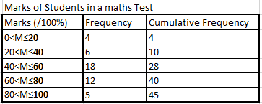

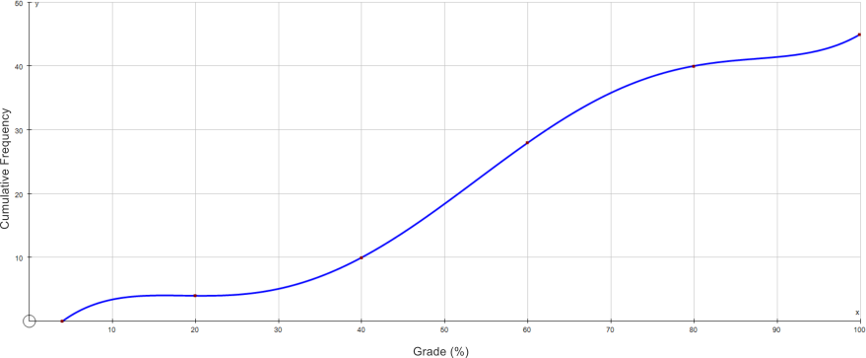

*Grade % Cumulative Frequency Graph*

##### Finding Information using Cumulative Frequency Graphs

Let us find the:

##### •median (estimated)

We can find the median by calculating half of the total cumulative frequency (22.5) and imagining a horizontal line passing through this point on the y axis. The x value of where this line cuts the curve is the median. In this case it is about 54.

##### lower & upper quartile (estimated)

We can find the quartiles by finding 1

4

and 3

4

of the total cumulative frequency

and then doing the same as we have done for the median. In this example, the lower quartile is approximately 42 and the upper quartile 65.

By using common sense and looking at the cumulative frequency graph we can also make logical statements such as:

•“The majority of students scored over 50%.”

•“Only 5 students scored 80% or more.”

•“4 students scored 20% or less.”

###### Example 2

The following example shows how to draw a cumulative frequency curve for grouped data.

Draw a cumulative frequency graph for the frequency table below.

|  |  |
| --- | --- |
| Length (x mm) | Frequency |
| 11 – 15 | 2 |
| 16 – 20 | 4 |
| 21 – 25 | 8 |
| 25 – 30 | 14 |
| 31 – 35 | 6 |
| 36 – 40 | 4 |
| 41 – 45 | 2 |

###### Solution:

|  |  |  |  |  |
| --- | --- | --- | --- | --- |
| Length (x mm) | Frequency | Upper Class Boundary | Length (x mm) | Cumulative Frequency |
| 6 – 10 | 0 | 10.5 | x ≤ 10.5 | 0 |
| 11 – 15 | 2 | 15.5 | x ≤ 15.5 | 2 |
| 16 – 20 | 4 | 20.5 | x ≤ 20.5 | 6 |

|  |  |  |  |  |
| --- | --- | --- | --- | --- |
| 21 – 25 | 8 | 25.5 | x ≤ 25.5 | 14 |
| 25 – 30 | 14 | 30.5 | x ≤ 30.5 | 28 |
| 31 – 35 | 6 | 35.5 | x ≤ 35.5 | 34 |
| 36 – 40 | 4 | 40.5 | x ≤ 40.5 | 38 |
| 41 – 45 | 2 | 45.5 | x ≤ 45.5 | 40 |

And then plot the cumulative frequency against the upper class boundary of each interval and join the points with a smooth curve.

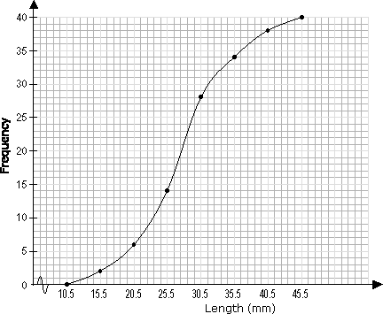

##### Exercise 3: To be done in groups and presented to the class

1. Consider the following data which shows the marks scored by students in a math test

|  |  |  |  |  |  |  |  |  |  |  |
| --- | --- | --- | --- | --- | --- | --- | --- | --- | --- | --- |
| Marks | 1-  10 | 11-  20 | 21-  30 | 31-  40 | 41-  50 | 51-  60 | 61-  70 | 71-  80 | 81-  90 | 91-  100 |
| Frequency | 2 | 6 | 15 | 20 | 24 | 32 | 12 | 4 | 3 | 2 |

|  |  |  |  |  |  |  |  |  |  |  |
| --- | --- | --- | --- | --- | --- | --- | --- | --- | --- | --- |
| Cumulativ e frequency | 2 | 6 | 21 |  |  |  |  |  |  |  |

* 1. Copy the table and complete the values for cumulative frequency. You find them by adding the next frequency to the preceding cumulative frequency.
  2. Using an appropriate scale, draw a graph with marks on the x-axis and cumulative frequency on the y-axis.

Mark the upper boundary of the marks against the cumulative frequency. For example, the first point is (10.5, 2)

* 1. Join the points with a smooth curve. This gives the **cumulative frequency graph** for the data (also called the **Ogive**)
  2. Find 1 𝑐𝑢𝑚𝑢𝑙𝑎𝑡𝑖𝑣𝑒 𝑓𝑟𝑒𝑞𝑢𝑒𝑛𝑐𝑦 = 120 = .

2 2

Read the mark on the x-axis that corresponds to this mark. This mark is the **median mark** for the data.

* 1. How can we get the mark that corresponds to a quarter of the data? How about three-quarters?

##### These are called the Quartiles.

**Upper quartile is value that corresponds to**

𝟑 𝒐𝒇 𝒕𝒉𝒆 𝒄𝒖𝒎𝒖𝒍𝒂𝒕𝒊𝒗𝒆 𝒇𝒓𝒆𝒒𝒖𝒆𝒏𝒄𝒚

𝟒

##### Lower quartile is the value that corresponds to

𝟏 𝒐𝒇 𝒕𝒉𝒆 𝒄𝒖𝒎𝒖𝒍𝒂𝒕𝒊𝒗𝒆 𝒇𝒓𝒆𝒒𝒖𝒆𝒏𝒄𝒚

𝟒

1. Measure the heights of members in your school mates. Ensure you have at least 50 values.
   1. Group the data into suitable classes.
   2. Find the modal class.
   3. Draw a cumulative frequency graph of your data.
   4. From your graph, find:
      1. the median
      2. the upper quartile
      3. the lower quartile
      4. the 10th percentile
      5. the 50th percentile
2. The table below shows the cumulative frequency distribution for the times taken by 100 students to eat lunch.

|  |  |
| --- | --- |
| Time(min) | Number of students(cumulative) |
| Under 2 min | 0 |
| Under 4 min | 6 |
| Under 6 min | 18 |
| Under 8 min | 24 |
| Under 10 min | 40 |
| Under 12 min | 60 |
| Under 14 min | 78 |
| Under 16 min | 92 |
| Under 18 min | 100 |
|  |  |

Using a scale of 1cm for 10 students on the vertical axis and 1 cm for 2 min on the horizontal axis, plot and draw a cumulative frequency graph.

Use your graph to estimate:

1. the median.
2. the upper quartile.
3. the lower quartile.
4. Given that 𝑰𝒏𝒕𝒆𝒓𝒒𝒖𝒂𝒓𝒕𝒊𝒍𝒆 𝒓𝒂𝒏𝒈𝒆 = 𝑼𝒑𝒑𝒆𝒓 𝒒𝒖𝒂𝒓𝒕𝒊𝒍𝒆 −

𝑳𝒐𝒘𝒆𝒓 𝒒𝒖𝒂𝒓𝒕𝒊𝒍𝒆**,** find the interquartile range for this data.

1. A school with 150 students is tested to see how many English words that start with M they can remember in one minute. The results are given below:

|  |  |  |
| --- | --- | --- |
| Number of words | Number of students | Cumulative frequency of  students |
| 1-3 | 11 | 11 |

|  |  |  |
| --- | --- | --- |
| 4-6 | 21 | 32 |
| 7-9 | 33 | P |
| 10-12 | Q | 99 |
| 13-15 | 38 | 137 |
| 16-18 | 13 | 150 |

* 1. Find the value of p and q.
  2. Draw a cumulative frequency graph using an appropriate scale.
  3. Use your graph to find:
     1. median number of words.
     2. the probability of students who remembered more than 5 words.
     3. if the pass mark was 10 out of 20 words, how many students passed.